Surlingham Parish Council

Minutes of the Parish Council meeting held on Tuesday 13th January 2026 in The Village Hall, Surlingham
(Subject to amendment until signed by the Chair at the next meeting)

Parish Councillors present Martin White (Chair), Dave Swinborne, Tim Mack, Pat Scowen
District Councillor Vic Thomson
Also in attendance Charlotte Rust, Clerk
Members of the public (MOP) Three

26.01 Welcome from the Chair.
Councillor White opened the meeting at 19:30pm and welcomed all those in attendance.
26.02 To receive and approve apologies for absence.
Councillors’ Wilson, Harris, and Mummery gave their apologies.
26.03 To receive any declarations of interest from Members & consider requests for dispensation.
None.
26.04 To approve the minutes of the Parish Council meeting held on 9th December 2025.
Councillor Scowen proposed for Councillor White to sign the approved minutes, seconded by Councillor Swinborne.
26.05 Matters arising from December’s meeting, including Clerk’s report.
Matters Arising
- Beerlick’s Loke – South Norfolk District Council’s Enforcement Team will be following up on the progress on a planning application.
- Gateways refund – the Clerk contacted Norfolk County Council’s cabinet member for Highways, Councillor Graham Plant raising the issue of costs over the Wig Wags and Gateways installation. He confirmed that the parish contribution for the gateways would reduce from £2,400 to £694.87 – a refund of £1,705.13. Along with a gesture of goodwill, agreed to an additional sum for interest and clerk’s time, as detailed in the figures below:
£1,705.13 refund
x 3.3% 2024 CPI = £1,761.40
x 3.5% 2025 CPI (November) = £1,823.05
+ £100 clerk time = £1,923.05 total refund
- Works planned to repair the surface damage to the gateways as you enter Surlingham from Bramerton.
- Wig Wag lights – Westcotec looked at the Wig Wags on 13th January 2026, and the inside unit needs replacing.
- No85 bus service – the Clerk has chased Transport Made Simple Group for an update on a community meeting.
- Eleven Says advertisement – the Clerk has submitted wording advertising the village hall for use.
- Flooding on Cut Loke – please see minute 26.15.01.
- Surlingham FP5 and FP1 update - Biodiversity Net Gain requirements of FP5 – update in coming weeks. However, the Clerk received an email from Andrew Middleton, Greenways Infrastructure Team Leader on 13th January 2026, detailing the project to improve the Wherryman’s Way at Bramerton has been suspended. The decision follows a significant and unexpected increase of approximately 700% in the cost of biodiversity net-gain measures - which are a legal requirement under current legislation. The rise in costs stems from an independent review commissioned by the Broads Authority who act as the planning authority in this instance. This has meant that the project is no longer financially viable, meaning the planning application has been withdrawn. The government has indicated that the rules around biodiversity net-gain for projects of this nature may change in the future. Should this happen, the project will be revisited.
Clerk’s Report
- The water heaters have been replaced in the hall meeting current regulations.
- Councillor Mummery confirmed he has completed a Risk Assessment ready to disassemble the broken tractor at the play area.
- Submitted the council’s responses to the Local Government Reorganisation questionnaire.
- Carried out a COSHH Risk Assessment and created a COSHH Register.
- Drafted Hall Hire agreements, to be reviewed at February’s meeting.
- Councillor White and the Clerk have a meeting with Surlingham School’s Headteacher on 27th January 2026 to discuss ongoing issues with the hall’s cleanliness.
- Continued scanning documents so all information is digital, ready to archive hardcopies at Norfolk County Council’s Archive Centre.
- Invoices issued for December’s hall hire totalling £114.50.
- All necessary correspondence forwarded to councillors.
26.06 Reports from:
26.06.01 County/District Councillor, Councillor Thomson.
Councillor Thomson gave an overview of his report; a full version will be available on the website:
- Update on Bramerton FP5 feasibility study – please see minute 26.05.
- RSPB has Riparian responsibilities on Surlingham Staithe and are planning an exploratory survey for clearance South of Moore’s Water and Bunny’s Broad.
26.06.02 Rivers, Ponds, Cycle/Footpaths.
None.
26.06.03 Councillor White – Play Area inspection.
Councillor White said no inspections had been conducted over the Christmas period. He will conduct an inspection shortly and will forward this to the Clerk.
26.06.04 Parish Clerk – Traffic and SAM2.
Site 9 (The Green, facing West) saw a higher vehicle count due to the festive period. The biggest increase in speed was 26-30mph which was up 21.8% and 31-35mph up 7.9% against the previous 4-week period. Please click the link for all SAM2 data for Surlingham - Traffic and SAM2 – Surlingham Parish Council.
Steve Gildersleeve suggested amendments to two SAM2 sites as Norfolk County Council had removed the posts:
Site 1 Mill Road, facing North - the post near the Gateways.
Site 13 and Site 14, Bramerton Road (Hill Farm House) – the bend signpost.
Site 3 and Site 4 – School Lane is to be removed.
Councillor White proposed to approve these changes, seconded by Councillor Swinborne.
The Clerk is to contact Norfolk County Council to request these changes.
26.07 Adjournment for Public Participation.
None.

26.08 Finance:
26.08.01 To receive the Bank reconciliation and Statement of Accounts as of 13th January 2026.
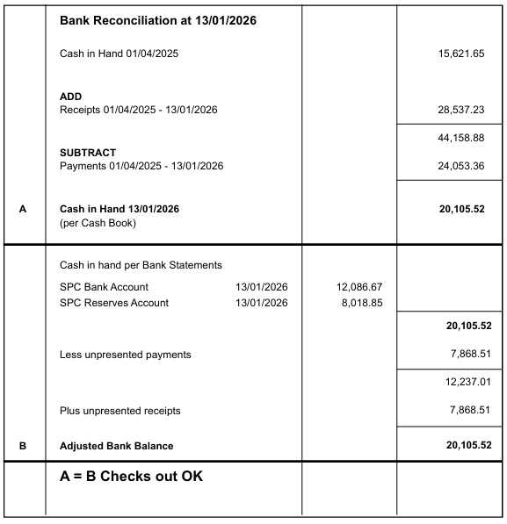

Councillor White proposed for the Chair and the Responsible Finance Officer sign the Bank Reconciliation dated 13th January 2026, seconded by Councillor Swinborne.
26.08.02 To note any receipts and approve payments as per January’s payment schedule.
FOR APPROVAL
 | DATE | EXPENDITURE | PAYMENT METHOD | TOTAL | VAT
Clerk | 14.01.26 | Jan expenses | BACS | £30.60 | £0.00
Clerk | 27.01.26 | Jan Salary and WFH | BACS | £646.80 | £0.00
HMRC | 14.01.26 | Employer NI Contribution up to 5th February 2026 | BACS | £57.25 | £0.00
S. Gildersleeve | 14.01.26 | November invoice | BACS | £50.00 | £0.00
PVS Plumbing | 14.01.26 | Water Heaters in Hall | BACS | £1,075.23 | £179.21
Orange Fox | 14.01.26 | Emergency and Lux test | BACS | £315.30 | £52.55
EDF | 20.01.26 | Electricity | DD | £594.15 | £246.53
TO NOTE PAYMENTS MADE OUTSIDE MEETINGS
Microsoft 365 | 06.01.26 | Cloud Storage | DC | £84.99 | £14.16
B and Q | 17.12.25 | Radiator Covers | DC | £116.97 | £19.50
Amazon | 08.01.26 | Emergency Lighting Test Ket | DC | £3.99 | £0.67
Poringland Library | 12.01.26 | Scanning original hall deeds/docs | DC | £2.00 | £0.00
Bookings Clerk/Cleaner | 15.01.26 | Jan Salary | SO | £131.00 | £0.00
Mr S Gildersleeve | 28.01.26 | Jan SAM2 | SO | £15.00 | £0.00
TO NOTE INCOME
 | 12.12.25 | Hall Hire | CHQ | £54.00 | £0.00
 | 12.12.25 | Hall Hire | CHQ | £54.00 | £0.00
 | 12.12.25 | Hall Hire | CHQ | £72.00 | £0.00
 | 15.12.25 | Hall Hire | CHQ | £18.00 | £0.00
 | 15.12.25 | Hall Hire | CHQ | £18.00 | £0.00
 | 19.12.25 | Hall Hire and Electricity | BACS | £2,108.48 | £0.00
 | 09.01.26 | Hall Hire and Electricity | BACS | £2,137.84 | £0.00
 | 09.01.26 | RSM Council Training | BACS | £93.87 | £0.00
 | 12.01.26 | KB Council Training | BACS | £40.23 | £0.00
Councillor White proposed to approve January’s Payment Schedule, seconded by Councillor Mack.
26.08.03 To consider the Clerk’s report for streamlining IT systems.
Councillor Mack proposed to approve the Clerk’s recommendation to streamline the council’s IT service and purchase digital mapping services from Parish Online in 2026/2027, seconded by Councillor Swinborne.
26.08.04 To receive a Payments and Receipts reports.
The Clerk gave an overview of the three reports she had prepared:
12-month period 01.01.2025 – 31.12.2025
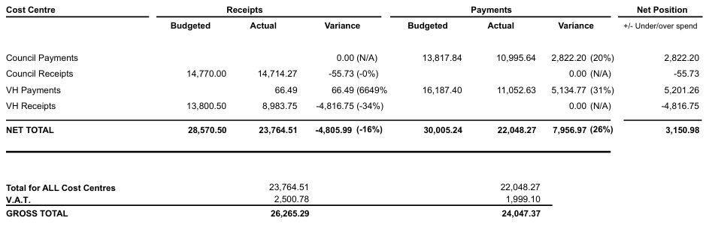

Overview of Financial Year 2024/2025

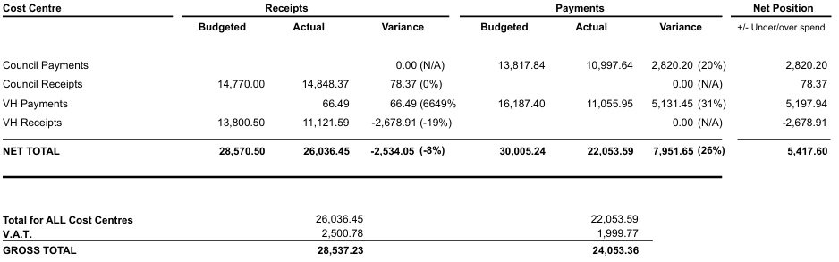
Year-to-Date of Financial Year 2025/2026

The Clerk will provide a full breakdown of Financial Year 2025/2026 at April’s meeting.

26.09 To receive and consider quotes for felling the Willow Tree at Surlingham Staithe.
The council had received quotes from:
Tree care and Conservation - £850+VAT
John C Service - £2040
Councillor Mack proposed to decline the quotes received and offered he and his team would complete the work following a Risk Assessment being carried out, seconded by Councillor Scowen.
The works will be completed before March 2026; however, the works are on hold as the ground is currently saturated.
26.10 Hall:
26.10.01 To discuss the village halls future.
The clerk is to research into running the hall:
- As a Charity
- With a Village Hall Committee
- With any other suitable recommendation
The Clerk is to report her findings at February’s meeting.
The Clerk informed the council that whilst the council has an Indenture from 1911 for the purchase of the Hall, it had not been registered with the Land Registry. The Clerk is liaising with solicitors, Wellers Hedley, to action this.
26.10.02 To receive an update on the radiator covers.
Councillor Mummery confirmed to the Clerk prior to the meeting that the covers she had purchased were not fit for purpose and provided her with some recommendations for her to research. The Clerk will return the covers.
26.10.03 To consider Electricity rates from February 2026.
Councillor Mack proposed to approve Yorkshire Gas & Power as the halls Electricity provider under a 24-month contract with an estimated annual cost of £5,608.34, seconded by Councillor Scowen. The Clerk will confirm fixed costs once the contract has been completed.
26.11 Play Area:
26.11.01 To receive an update on the Public Consultation Project.
The Clerk informed the council that the consultation will take place in the Easter holidays and that there were no further updates due to investigating the Hall Deeds.
26.11.02 To receive an update regarding the removal of the tractor play equipment.
Please see minute 26.05.
26.12 Council Assets:
26.12.01 To receive an update on grit bin levels in the parish.
Councillor Swinborne confirmed that the Ferry Corner grit bin was full.
Councillor Mack confirmed that The Green grit bin was full.
The Clerk is to investigate relocating the Ferry Corner grit bin.
26.13 Policies:
26.13.01 Emergency Plan.
This item is deferred to February’s meeting.
26.14 Planning:
26.14.01 Applications:
26.14.01.01 2025/3889 – Broad Cottage - Upgrade of septic tank with package treatment plant.
The council unanimously supported this application.
26.15 Correspondence:
26.15.01 Flooding on Cut Loke.
The Clerk informed the council that there had been further flooding in this area. The landowner confirmed he will investigate this and update the council at February’s meeting.
26.16 To receive updates from individual Council Members (for information only).
The Clerk asked Councillors if they can forward on any amendments to documents prior to the meeting if possible, helping the Council keep in line with its Standing Orders, section 3y – A meeting shall not exceed a period of 2 hours.
26.17 To receive any items for inclusion on the next agenda (for information only).
Emergency Plan.
26.18 To confirm date and time of the next meeting as Tuesday 10th February 2026 at 7.30pm in Surlingham Village Hall.
Confirmed. The Clerk reminded Councillors that there was in-house Internal Control Check training before February’s meeting.

The meeting closed at 21:27pm

