Surlingham Parish Council

Minutes of the Parish Council meeting held on Tuesday 13th May 2025 in The Village Hall, Surlingham
(Subject to amendment until signed by the Chair at the next meeting)

Parish Councillors present Chair Martin White, Vice-Chair Pam Wilson, Dave Swinborne, Tim Mack
District Councillor None
Also in attendance Charlotte Rust, Clerk
Members of the public (MOP) One

25.73 Welcome from the Chair.
Chair White opened the meeting at 19:31pm and welcome all those in attendance.
25.74 To elect a Chair/Vice-Chair and receive signed Declarations of Office(s).
Councillor Wilson proposed to elect Councillor White as Chair, seconded by Councillor Mack.
Councillor Swinborne proposed to elect Councillor Wilson as Vice-Chair, seconded by Councillor White.
The clerk received signed copies of Declarations of Office.
25.75 To receive and approve apologies for absence.
Councillors’ Atkins, Harris and Scowen gave their apologies.
25.76 To receive any declarations of interest from Members & consider requests for dispensation.
Councillor Mack declared an interest in agenda item 19.1.1 (minute 25.91.01.01).
25.77 To approve the minutes of the Parish Council meeting held on 11th March and 23rd April 2025.
Councillor Wilson proposed for Councillor White to sign the approved March meeting minutes, seconded by Councillor Mack.
Councillor White proposed to sign the approved April meeting minutes, seconded by Councillor Swinborne.
25.78 Matters arising from March and April’s meeting, including Clerk’s report.
Matters Arising:
- Tree Audit – defer until June’s meeting.
- Meeting with School – Councillor White had to cancel the arranged meeting due to illness and has struggled to reschedule it with the Headteacher.
- Gateways meeting – Highways, Councillor White and the landowners met on 9th May 2025 to discuss a new location for the village gateways which was agreed about 2/3 metres past the new 30mph sign on the left-hand side on Bramerton Road. Part of the nearby hedge will be removed to prevent the gateways being covered. The lead time is 10-12 weeks.
- Tractor – Thank you to Steve Gildersleeve who repaired the play area tractor but the four posts that go into ground are rotten. Steve will have a look to see if he can remove the rotten part of the posts and report back to the council to consider further action if required.
Clerk’s Report:
- Thank you to David Driver who put in a new post and fixed the dog bin near the Church after it fell.
- Thank you to Councillor Mack and Will Mack for clearing the pond area.
- Contacted Norfolk County Council regarding Wherrymans Way, Caroline Bidewell has recently joined the Norfolk Trails team and the feasibility work for Surlingham FP1 should be starting towards the end of the month. The regular meeting is something she is looking to organise again, from June/July, to provide updates to stakeholders with progress made across the trail.
- Report the water leak on Walnut Hill to Anglian Water. Councillors advised there is another leak on Walnut Hill and asked the clerk to report this.
- Replied to CPRE regarding South Norfolk District Council’s new town proposal.

- Ferry Road and School Lane trees – Norfolk County Council assessed criteria and does not meet its criteria for repair.
- Ditches guidance – Norfolk County Council has assessed the area and no further action. The clerk has responded confirming the council was seeking guidance on ditches not reporting any issues.
- Updated Internal Control Check, Grievance and Disciplinary policies and now available on the website.
- Reworded clause 7.2 of cleaner contract and amended sickness policy to include clerk.
- School requested to purchase and install fingerguards on doors following installation of replacement back door. The chair and clerk approved this.
- Reported issues on Surlingham FP1 and FP3 to Norfolk County Council.
- Utilising Scribe Accounts for the council’s accounts package.
- Submitted comments on South Norfolk District Council’s online portal regarding 2025/0665 planning application.
- The council has received £90 of CIL funds for application reference 2022/1505 (Erection of annexe and store to rear of dwelling (Retrospective) at 51A The Street, Surlingham). The total CIL to be paid on this site is £4,774.56, of which 15% is paid to the council in instalments every 6 months. The council unanimously voted to transfer the funds to reserves.
- Submitted and passed module 3 of CiLCA. Councillors congratulated the clerk.
- Society of Local Clerks and Council’s Norfolk conference is being held on June 20th. The £38 cost will be split 3 ways in line with the signed shared training agreement.
- All necessary correspondence forwarded.
25.79 Reports from:
25.79.01 County/District Councillor, Councillor Thomson.
None.
25.79.02 Councillor Atkins – Rivers, Ponds, Cycle/Footpaths.
- I have drafted a letter to the Broads Authority regarding dredging the Staithe referring to the Broads Act definition of the navigational area, Broad Authority’s responsibilities to maintain navigation and previous correspondence with the Broads Authority regarding the Staithe navigation. The clerk is to send this when she has been forwarded it.
- I had a very positive call with Caroline Bidewell who took over the Norfolk County Council Trails team in November. We walked through some of the history and issues with the Surlingham paths. That said the junction of FP1 and FP3 remains in a very poor state so please could this be followed up formally. The clerk is to action this.
- Pond water level very low. I have levelled the remainder, and the new sign looks smart. Old sign now requires removal.
25.79.03 Councillor White – Play Area inspection.
Councillor White is to forward on the completed inspections to the clerk.
25.79.04 Parish Clerk – Traffic and SAM2.
- The clerk noticed an error in how the data was downloaded meaning the data provided is incorrect, she will correct this after AGAR 24/25 is submitted and completed.
- Steve Gildersleeve is monitoring the battery on the SAM2 as it has been reported that it does not always flash accordingly.
- Councillor Mack proposed to amend the SAM2 location on the corner of the ‘dead end’ road on Bramerton Road near Surlingham Lodge to the 30-mph sign that is opposite Surlingham Lodge further down, seconded by Councillor White. The clerk is to action.
- Councillor Wilson proposed to follow the order of locations as detailed in the Memorandum of Understand between Surlingham Parish Council and Norfolk County Council for the SAM2, seconded by Councillor Swinborne.
25.80 Adjournment for Public Participation (15 min).
A member of the public asked how the Wherrymans Way regular updates would happen. The clerk confirmed details hadn’t been confirmed.
25.81 Finance:
25.81.01 To receive a Statement of Accounts as of 13th May 2025.
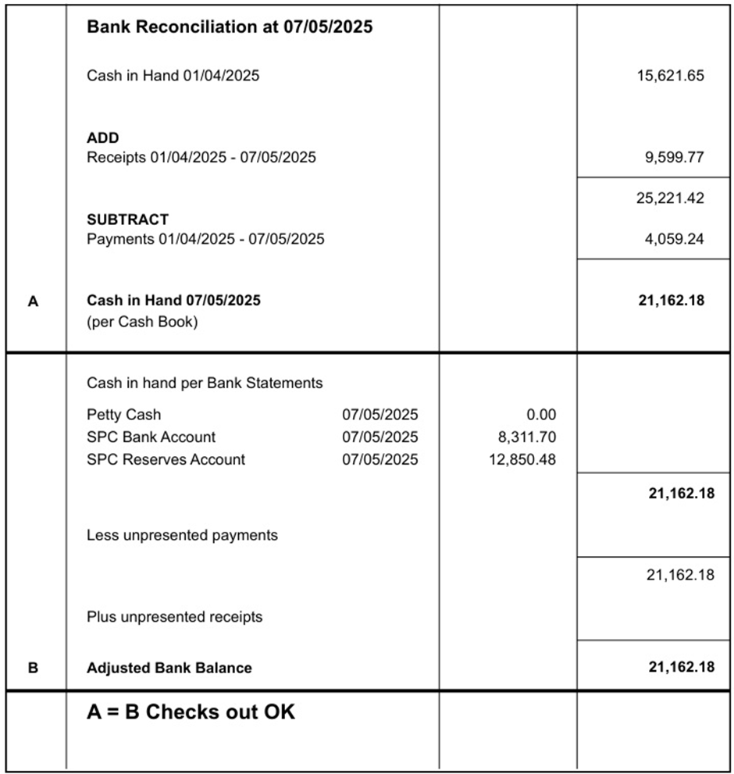
Councillor Swinborne proposed for the Chair and Responsible Finance Officer to sign the bank reconciliation as of 7th May 2025, seconded by Councillor Mack. The clerk confirmed this bank reconciliation reflected the balances as of 13th May 2025 as no further transactions had taken place.
25.81.02 To note any receipts and approve payments as per May’s payment schedule.
FOR APPROVAL
 | DATE | EXPENDITURE | PAYMENT METHOD | TOTAL | VAT | P/R NO
Clerk | 13.05.25 | May expenses | BACS | £30.60 | £0.00
Clerk | 28.05.25 | May studying | BACS | £76.65 | £0.00
Clerk | 28.05.25 | Salary/study increase back pay | BACS | £56.61 | £0.00
HMRC | 13.05.25 | PAYE to 5th May | BACS | £11.60 | £0.00
HMRC | 13.05.25 | Employer NI Contribution | BACS | £25.40 | £0.00
Frettenham PC | 09.05.25 | Play Area Training | BACS | £53.33 | £0.00
C. Clitheroe | 13.05.25 | Exterior works/repairs for hall | BACS | £142.00 | £0.00
SLCC | 13.05.25 | 2025 Conference | BACS | £38.00 | £0.00
WAVE | 28.03.25 | Water 25/26 | BACS | £964.84 | £0.00
TO NOTE PAYMENTS MADE OUTSIDE MEETINGS
EDF | 22.04.25 | Electricity | DD | £1,774.16 | £295.69 | P11
EDF | 21.05.25 | Electricity | DD | £945.72 | £157.62
Bookings Clerk/Cleaner | 15.05.25 | May Salary | SO | £131.00 | £0.00
Clerk | 28.05.25 | May Salary & WFH | SO | £516.56 | £0.00
Mr S Gildersleeve | 28.05.25 | May SAM2 | SO | £15.00 | £0.00
TO NOTE INCOME
 | 08.04.25 | Hall Hire | CHQ | £24.00 | £0.00 | R1
SNDC | 17.04.25 | CIL payment | BACS | £90.00 | £0.00 | R2
HMRC | 22.04.25 | VAT Claim (Jan-Mar 25) | BACS | £946.27 | £0.00 | R3
SNDC | 25.04.25 | April Precept | BACS | £7,000.00 | £0.00 | R4
 | 25.04.25 | Hall Hire and Electricity | BACS | £1,527.30 | £0.00 | R5/R6
Clerk | 28.05.25 | HMRC PAYE to 5th May | BACS | £11.60 | £0.00
TRANSFERS
To Bank Account | 09.04.25 | Cover back door payment | TRANSFER | £771.17 | £0.00
To Bank Account | 22.04.25 | Cover payments until precept | TRANSFER | £1,000.00 | £0.00
Councillor White proposed to approved May’s payment schedule, seconded by Councillor Wilson.
25.82 To consider providing the maintenance contractor with a set of keys for the hall.
Councillor Wilson proposed to give the maintenance contractor one of the spare sets of hall keys, seconded by Councillor White.
25.83 To consider and approve annual contract for pest control at village hall.
Councillor Wilson proposed to approve the clerk’s recommendation to award AAA Pest Control the annual contract of £112.50 per quarter, seconded by Councillor White
25.84 To consider and approve quote for gutter and window cleaning.
Councillor White proposed to approve the clerk’s recommendation to proceed with Under Pressure’s quote of £206.50, seconded by Councillor Swinborne.
25.85 To consider and approve annual insurance quote.
Councillor White proposed that the clerk use her discretion to select the most suitable, cost-effective cover for the council, upon receipt of all insurance quotes, seconded by Councillor Swinborne.
25.86 To approve and consider quotes for Staithe maintenance.
This item is deferred until June.
25.87 To consider Friends of Surlingham School’s request for free hall hire during the summer fete.
Councillor Swinborne proposed to provide Friends of Surlingham School with free hall hire for the summer fete being held on Saturday 7th June 2025, seconded by Councillor Wilson.
25.88 To consider the consultation of the Public Spaces Protection Order (Dog Fouling & Dog Control).
Noted.
25.89 Internal Control Checks:
25.89.01 To approve July – September 2024; led by Councillor Swinborne.
Councillor White proposed to approve July-September 2024’s internal control check, seconded by Councillor Mack. The clerk apologised for the typographical error in the year on the agenda.
25.89.02 To approve January – March 2025; led by Councillor Harris.
This item is deferred until June.
The clerk confirmed the internal control checks will be completed differently since the introduction of an accounting system and will arrange a training session for councillors.
25.90 Policies:
25.90.01 Complaints.
Councillor Swinborne proposed to approve the policy subject to the removal of wording in the first sentence ‘(or a compliment)’, seconded by Councillor Mack.
25.90.02 Financial Regulations.
Councillor White proposed to approve the policy and the clerk’s recommended amendments, seconded by Councillor Mack.
25.91 Planning:
25.91.01 New applications:
25.91.01.01 2025/1227 – Land East of Mill Road – Erection of three self-build dwellings and associated change of use of agricultural land to residential.
In line with the council’s Standing Orders s12b, Councillor Mack left the meeting at 20:34pm.
Councillor Wilson proposed to submit a neutral stance on the planning permission with comments relating to the Oak trees, seconded by Councillor White.
Councillor Mack returned to the meeting at 20:42pm.
25.91.02 Decisions:
25.91.02.01 2025/0263 – 18 The Green - Demolition of existing dwelling and outbuilding and erection of new dwelling and single garage; SOUTH NORFOLK DISTRICT COUNCIL APPROVED WITH CONDITIONS.
Noted.
25.91.02.02 2023/1261 – New Barn - Change of use from redundant agricultural barn to a single dwelling; SOUTH NORFOLK DISTRICT COUNCIL APPROVED WITH CONDITIONS.
Noted.
25.91.02.03 2025/0683 – The Grange – Agricultural store; SOUTH NORFOLK DISTRICT COUNCIL PRIOR APPROVAL NOT REQUIRED.
Noted.
25.91.02.04 2022/0857 - Brickyard Farm - Discharge of conditions 2, 4, 5, 6 and 7 from 2018/2289 - (2) hedge planting (4) flood event (5) flood response plan (6) passing bays (7) vehicle wash-down; SOUTH NORFOLK DISTRICT COUNCIL APPROVED.
Noted.
25.92 Correspondence:
25.92.01 Finger guards on hall door frames.
Please refer to minute 25.78.
25.92.02 Gateway update.
Please refer to minute 25.78.
25.93 To receive updates from individual Council Members (for information only).
Councillor White confirmed he is waiting for dates from Daniel North at Highways to discuss a new location for the disputed west post for the wig wags.
25.94 To receive any items for inclusion on the next agenda (for information only).
Planning Policy.
25.95 To confirm date and time of the next meeting as Tuesday 10th June 2025 at 7.30pm in Surlingham Village Hall.
Confirmed.

The public section of the meeting closed at 20:51pm

25.96 Resolution to exclude members of the public and press under the Public Bodies (admission to Meetings) Act 1960.
Councillor White closed the meeting to all public attendees.
25.96.01 To consider and approve Cleaner/Booking Clerk’s contract and Sickness and Absence policy.
Councillor Swinborne proposed to approve the Cleaner/Booking Clerk’s contract, seconded by Councillor Wilson.
Councillor White proposed to approve the Sickness and Absence policy, seconded Councillor Mack.
25.96.02 To consider the clerk’s appraisal and pay increase.
Councillor Swinborne proposed to approve the clerk’s appraisal and pay increase from Spinal Column Point 16 to Spinal Column Point 18, seconded by Councillor Wilson.

The meeting closed at 21:05pm.

