Surlingham Parish Council

Minutes of the Parish Council meeting held on Tuesday 9th September 2025 in The Village Hall, Surlingham
(Subject to amendment until signed by the Chair at the next meeting)

Parish Councillors present Chair Martin White, Dave Swinborne, Pat Scowen, Tim Mack
District Councillor None
Also in attendance Charlotte Rust, Clerk
Members of the public (MOP) One

25.138 Welcome from the Chair.
Councillor White opened the meeting at 19:32pm and welcomed all those in attendance.
25.139 To receive and approve apologies for absence.
Councillors’ Harris and Wilson gave their apologies. Also, County/District Councillor Thomson gave his apologies.
25.140 To receive any declarations of interest from Members & consider requests for dispensation.
None.
25.141 To approve the minutes of the Parish Council meeting held on 8th July 2025.
Councillor Mack proposed for Councillor White to sign the approved minutes, seconded by Councillor Swinborne.
25.142 Matters arising from July’s meeting, including Clerk’s report.
Matters arising:
- Beerlick’s Loke – No further updates have been received. The clerk is to follow up.
- Gateway installation – Parishioners may have noticed advance road closure signs posted on Bramerton Road ahead of the planned gateway installations. However, the signage has been placed incorrectly. The Parish Clerk will be contacting Highways to confirm the precise location for the new gateways and to clarify whether Mill Road will also be closed for the installation.
- Drains on The Green – Work has been scheduled to jet and clear all Highways drainage. The clerk is to follow up on this as at the time of the meeting the works had not been completed.
- Hearing Loop – The clerk explained that the legal requirements under the Equality Act 2010 remain ambiguous. Various specialists are unable to confirm whether not installing a hearing loop due to costs would be deemed unreasonable. Councillor Mack proposed not to proceed with installing a hearing loop in the village hall, seconded by Councillor Swinborne.
- Council training – The clerk is to reschedule the council training for January/February 2026.
25.143 Reports from:
25.143.01 County/District Councillor, Councillor Thomson.
None.
25.143.02 Rivers, Ponds, Cycle/Footpaths.
Footpath 3 is severely degraded and is permanently under water. The clerk is to request an update on this as it is part of Wherrymans Way.
The clerk is to speak with Mr Atkins to ask if he is available to clear out the pond as it is quite full.
The clerk is to obtain quotes for Staithe dredging.
25.143.03 Councillor White – Play Area inspection.
Councillor White forwarded the play area inspections carried out to the clerk.
The clerk has spoken with Mr Gildersleeve regarding repairing the vandalism of the tractor. Councillors’ Swinborne and Wilson will carry out the inspection over the next couple of months.
25.143.04 Parish Clerk – Traffic and SAM2.

The clerk is continuing to download the SAM2 data, although transferring it into an Excel spreadsheet has proven more challenging than anticipated. She is actively working on resolving the issue and will ensure all data is backdated once the spreadsheet is complete.
25.144 Adjournment for Public Participation.
A member of the public confirmed that the Lunch Club will be continuing and being held in September following discussion with Aspen. The council would like to thank Janet Rogers for her hard work in keeping the Lunch Club going.
25.145 Finance:
25.145.01 To receive a Statement of Accounts as of 9th September 2025.
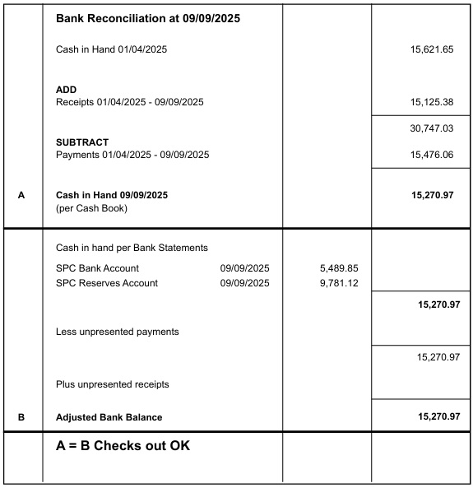
Councillor Scowen proposed for the Chair and Responsible Finance Officer to sign the Bank Reconciliation dated 9th September, seconded by Councillor Swinborne.
25.145.02 To receive an update of the council’s reserves budget.
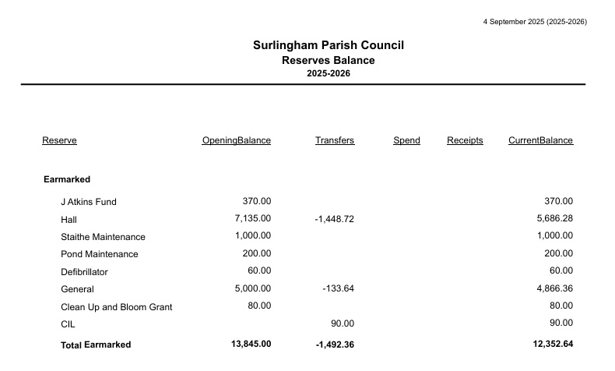

25.145.03 To approve the clerk’s salary increase in line with the Local Government Services Pay Agreement 2025.
Councillor White proposed to approve the clerk’s salary increase, seconded by Councillor Mack.
25.145.04 To note any receipts and approve payments as per September’s payment schedule.
FOR APPROVAL
 | DATE | EXPENDITURE | PAYMENT METHOD | TOTAL | VAT | P/R NO
Clerk | 10.09.25 | Sept expenses | BACS | £30.60 | £0.00
Clerk | 29.09.25 | Sept Salary | BACS | £712.44 | £0.00
HMRC | 10.09.25 | Employer NI Contribution up to 5th September | BACS | £12.13 | £0.00
HMRC | 10.09.25 | PAYE up to 5th October | BACS | £39.80 | £0.00
HMRC | 10.09.25 | Employer NI Contribution up to 5th October | BACS | £46.39 | £0.00
NPTS | 30.07.25 | Council training | BACS | £354.00 | £59.00
Supply Direct | 31.07.25 | Litter bin for play area | BACS | £235.99 | £39.33
Norfolk Fire Protection | 05.08.25 | VAT on report | BACS | £59.80 | £0.00
South Norfolk | 01.09.25 | Dog bins | BACS | £338.40 | £56.40
Cleaner | 10.09.25 | Expenses | BACS | £44.00 | £7.33
PKF Littlejohn | 29.08.25 | External Audit | BACS | £252.00 | £42.00
AAA Pest Control | 29.08.25 | Quarterly invoice | BACS | £112.50 | £0.00
Minuteman Press | 31.07.25 | Gate signs - Please lock gates | BACS | £29.52 | £4.92
TO NOTE PAYMENTS MADE OUTSIDE MEETINGS
Timpson | 23.05.25 | Keys cut for back door | DC | £19.00 | £0.00 | P24
Amazon | 27.05.25 | Noticeboard key holder | DC | £5.99 | £1.00 | P26
Norfolk Fire Protection | 28.07.25 | H & S Report for hall | BACS | £299.00 | £0.00 | P58
HMRC | 18.07.25 | PAYE and NI up to 5th August | BACS | £12.33 | £0.00
Bookings Clerk/Cleaner | 15.09.25 | Sept Salary | SO | £131.00 | £0.00
Mr S Gildersleeve | 29.09.25 | Sept SAM2 | SO | £15.00 | £0.00
TO NOTE INCOME
Claxton PC | 12.06.25 | SLCC Membership shared cost | BACS | £82.01 | £0.00 | R17
 | 07.07.25 | Hall Hire | CHQ | £18.00 | £0.00 | R18
HMRC | 11.07.25 | VAT Claim Apr-Jun | BACS | £634.85 | £0.00 | R19
 | 21.07.25 | Hall Hire | CHQ | £18.00 | £0.00 | R20
 | 21.07.25 | Hall Hire | CHQ | £72.00 | £0.00 | R21
 | 21.07.25 | Hall Hire | CHQ | £18.00 | £0.00 | R22
 | 25.07.25 | Hall Hire | BACS | £50.00 | £0.00 | R23
 | 01.08.25 | Hall Hire | CHQ | £27.00 | £0.00 | R24
 | 01.08.25 | Hall Hire | CHQ | £40.50 | £0.00 | R25
 | 01.08.25 | Hall Hire | CHQ | £18.00 | £0.00 | R26
 | 05.09.25 | Hall Hire and Electricity | BACS | £2,380.99 | £0.00 | R27
Barclays | 08.09.25 | Interest | BACS | £36.89 | £0.00 | R30
Councillor Mack proposed to approve the payment schedule, seconded by Councillor White.

25.146 To receive an update regarding the Christmas light event.
This item is deferred until October’s meeting.
25.147 To discuss the Food bank.
The council would like to thank Louise Atkins for volunteering to continue checking on the food bank. The clerk is waiting on clarification if the council’s insurance policy covers the food bank and will update the council at October’s meeting.
The clerk is to ask Mrs Atkins for feedback on the usage of the food bank and ask Mr Gildersleeve to clear and tidy the area around the bank.
The council will promote the food bank on its website.
25.148 To discuss the planned soakaway for Ferry Road.
The clerk is to contact Highways questioning why Ferry Road has been prioritised over The Green in relation to flood management.
25.149 Policies:
25.149.01 Data Audit.
Councillor White proposed to approve the Data Audit 2025, seconded by Councillor Swinborne.
25.149.02 Equality and Diversity.
Councillor White proposed to approve the Equality and Diversity policy, seconded by Councillor Mack.
25.150 Planning:
25.151.01 Applications:
25.150.01.01 2025/2468 – Mayfield – Front Porch.
Councillor Swinborne proposed that the council support planning application 2025/2468 with no comments made on South Norfolk District Council’s planning portal, seconded by Councillor Mack.
25.150.01.02 BA/2025/0220/FUL – Bramerton Footpath 5 - Improvements to footpath and replacement footbridge.
Councillor White proposed the council support planning application BA/2025/0220/FUL and provide a comment to the Broads Authority, seconded by Councillor Swinborne.
25.151.02 Decisions: None at the time of publication.
Noted.
25.152 Correspondence:
25.152.01 Extension at Flint Cottage.
The clerk received correspondence from 3 parishioners raising concerns over planning permission regarding the extension. The clerk forwarded their comments to South Norfolk’s Enforcement Team who confirmed ‘that the works currently taking place fall within permitted development and do not require planning permission. In view of this no further action can be taken on the matter.’ The parishioners have requested for clarification on what the criteria is for granting/denying planning permission. The clerk will forward on South Norfolk’s Enforcement Team’s response when she receives it.
25.152.02 City Fibre installation within the village.
Councillor White has raised the parishioners concerns regarding the access disruption and inconvenience caused by City Fibre installing fibre broadband to County Councillor Thomson, along with pictures of all the forthcoming road closures within Surlingham. The clerk is to chase Anglian Water regarding the leak on Walnut Hill as the road was due to be closed in August however as only closed on 3rd September which was when school returned causing further disruption.
25.153 To receive updates from individual Council Members (for information only).
Concerns were raised on the development of Greenacres, the plans that were provided to the council differ from the current scope of works. The council were not informed of the submission of revised plans.
Councillor White gave his apologies for October’s meeting.
25.154 To receive any items for inclusion on the next agenda (for information only).
Christmas lights.
Staithe dredging.
Budget.
Play area equipment.
25.155 To confirm date and time of the next meeting as Tuesday 14th October 2025 at 7.30pm in Surlingham Village Hall.
Confirmed.

The meeting closed at 20:59pm.

