Surlingham Parish Council

Minutes of the Parish Council meeting held on Tuesday 14th October 2025 in The Village Hall, Surlingham
(Subject to amendment until signed by the Chair at the next meeting)

Parish Councillors present Dave Swinborne, Pat Scowen (Acting Chair), Gary Harris, Howard Mummery
District Councillor Vic Thomson – Left the meeting at 20:24pm
Also in attendance Charlotte Rust, Clerk
Members of the public (MOP) Three, which went down to two after the co-option of Councillor Mummery.

25.156 Welcome from the Chair.
Councillor Scowen opened the meeting at 19:33pm and welcomed all those in attendance.
25.157 To receive and approve apologies for absence.
Councillors’ White, Wilson, and Mack gave their apologies.
25.158 To receive any declarations of interest from Members & consider requests for dispensation.
None.
25.159 To consider the co-option of a new councillor to fill a vacancy.
The council recognised that the applicant had not resided in Surlingham for the preferred 12-month period specified in the Co-option Policy but considered the individual to be an asset to the council.
Howard Mummery provided information about his application and answered councillors’ questions. Councillors White and Wilson had given their support of this co-option application via email.
Councillor Swinborne proposed to approve the co-option of Howard Mummery, seconded by Councillor Harris. The council voted, by a show of hands, FOR – 3 AGAINST – 0.
The clerk received a signed copy of the Declaration of Office.
25.160 To approve the minutes of the Parish Council meeting held on 9th September 2025.
Councillor Swinbourne proposed Councillor Scowen signed the approved minutes, seconded by Councillor Harris.
25.161 Matters arising from September’s meeting, including Clerk’s report.
Matters arising:
- Beerlick’s Loke – the Enforcement Team at South Norfolk District Council is waiting to receive a planning application from the landowner before further action is taken.
- Gateways – works completed. The clerk is to contact Councillor Thomson regarding a refund for the cost difference of the gateways which were requested as part of the Parish Partnership Scheme and of those actually installed.
- Drains on The Green – works were completed 19th August 2025 by Norfolk County Council.
- Food Bank – advertised service on both council and village website and Facebook pages.
- Council training – confirmed date is Wednesday 21st January 2025 between 7-9:30pm. The clerk is to contact Claxton, Rockland St Mary with Hellington and Kirby Bedon Parish Councils to offer a place on this training.
- Pond – Richard Atkins confirmed will clear the pond late Autumn/Early Winter. He will forward a management plan.
- Water leak on Walnut Hill – resolved by Anglian Water
- Play area meetings – the clerk has met with several play area providers to obtain quotes and guidance for either replacement equipment or repairs to existing equipment. The clerk will provide councillors with report of her findings at November’s meeting.
Clerk’s report:
- Martyn’s Law – officially known as the Terrorism (Protection of Premises) Act 2025 which aims to enhance security measures at public venues, and it is expected that the implementation period will be at least 24 months. The clerk will be attending a webinar on 21st October outlining what it means for all premises and next steps. Councillor Harris will forward on a contact to the clerk who may be able to assist with the next steps.
- Road closures email to Councillor Thomson from Councillor White – Councillor Thomson clarified that Norfolk County Council and South Norfolk District Council are not notified of road closures for a 24-hour period in an emergency, defined by a utility company. He recommended visiting Causeway one.network for the most up-to-date road closures.
- Footpath 1 feasibility study and Footpath 3 under water – the clerk contacted the Norfolk Trails team on 16th September and forwarded their response to councillors on 26th September. The team apologised for the delay due to staff illness. Footpath 3 is due to be repaired within the next couple of weeks and the feasibility study of footpath 1 remains on the Green Infrastructure programme.
- Ferry Road soakaway – emailed Highways on 16th September and received a response on 10th October:
‘The new soakaway installation on Ferry Road was confirmed following a request from a resident who had health issues and was experiencing issues with ice forming on the Highway at the intersection of their driveway, which was causing them issues accessing their property on foot and by vehicle. Upon investigation we found that the existing Highway drainage apparatus at this location was not functioning, and the outfall was no longer viable, so the only option was to install a soakaway to resolve the matter.’
- Data Audit and Equality policies updated and on website.
- Flint Cottage – emailed the Enforcement Team requesting further clarification on the regulations on Permitted Development on 16th September. The Enforcement Team confirmed on its first visit the development was within the regulations but will visit the site again in October. Emailed parishioners with the Enforcement Teams information.
- Transport Made Simple Group has purchased Go East Anglia, however Konectbus will continuing trading as is. In Jan 2026, a series of changes will be made to integrate services from all TMSG operators then Easter 2026 refining the network based on extensive consultation with passengers. The clerk is to contact neighbouring parish councils to arrange a meeting with the Transport Made Simple Group at one location.
- Created a page on the council’s website detailing the councils General Powers of Competence.
- VAT claim submitted for July – September 2025.
25.162 Reports from:
25.162.01 County/District Councillor, Councillor Thomson.
Councillor Thomson gave an overview of his report; a full version will be available on the website:
- Local Government Reform – 3 proposals have been put forward.
- Norfolk County Council is meeting on 16th October to decide whether to agree a new combined Mayoral authority with Suffolk.
25.162.02 Rivers, Ponds, Cycle/Footpaths.
Rivers – Councillors’ Harris and Scowen are researching the impact of river flooding within the village.
Ponds – please see minute 25.161.
Footpaths – Norfolk Trails team confirmed Wherrymans Way is not a cycling route.
25.162.03 Play Area inspection.
The clerk confirmed that the weekly inspections had been conducted and that the multi play steps had been repaired.
25.162.04 Parish Clerk – Traffic and SAM2.
The clerk has resolved the spreadsheet issue and has updated the website with the correct data. She provided an overview of the data from November 2024 – September 2025:
- Average speeds ranged from just under 30mph to approximately 34mph across periods.
- Jul–Sep deployments showed the highest average speeds.
- Speeding incidents were more frequent during early mornings and late evenings.
- Notable increase in vehicle counts during school holidays.
To view all SAM2 data, please visit: Traffic and SAM2 – Surlingham Parish Council
25.163 Adjournment for Public Participation (15 min).
A parishioner thanked the council for contacting Norfolk County Council regarding the blocked drains on The Green. Highways came out and cleared the drain but raised concerns over the drainage system. Please see minute 25.166.02.
The clerk is to compose wording for the website and Facebook with a polite reminder that the roads are a shared space.
25.164 Finance:
25.164.01 To receive a Statement of Accounts as of 14th October 2025.
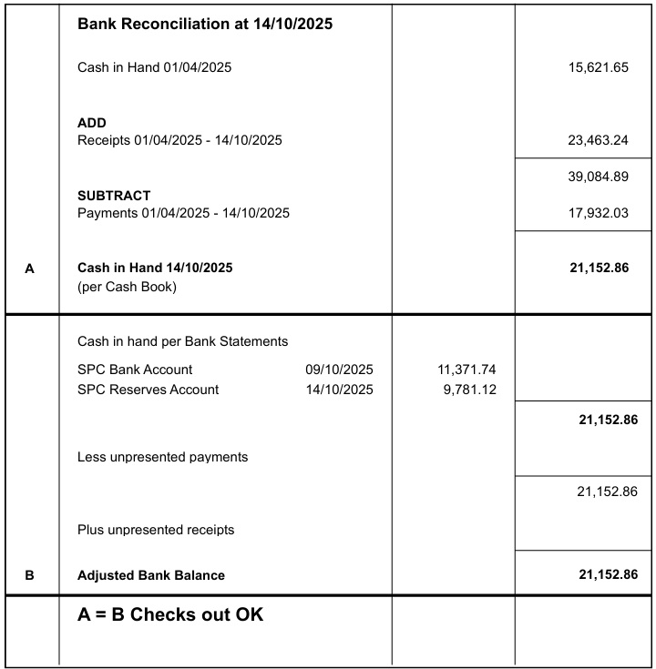

Councillor Harris proposed for Councillor Scowen and the Responsible Finance Officer to sign the bank reconciliation dated 14th October 2025, seconded by Councillor Swinborne.
Following a query from a councillor, the clerk confirmed that the actual year-to-date figures for electricity were £3,468.67 as the total included quarter 4 of 2024/25.
25.164.02 To note any receipts and approve payments as per October’s payment schedule.
FOR APPROVAL
 | DATE | EXPENDITURE | PAYMENT METHOD | TOTAL | VAT | P/R NO
Clerk | 15.10.25 | Oct expenses | BACS | £36.72 | £0.00
Clerk | 27.10.25 | Oct Salary | BACS | £646.60 | £0.00
HMRC | 15.10.25 | Employer NI Contribution up to 5th November | BACS | £57.45 | £0.00
Surlingham School | 15.10.25 | Playing field maintenance | BACS | £250.00 | £0.00
Surlingham PCC | 15.10.25 | Grant for burial ground | BACS | £250.00 | £0.00
S. Gildersleeve | 15.10.25 | May Invoice - rail in storage area | BACS | £50.00 | £0.00
S. Gildersleeve | 15.10.25 | June Invoice - grass cutting | BACS | £80.00 | £0.00
S. Gildersleeve | 15.10.25 | July Invoice - Tractor and play area repairs | BACS | £119.02 | £0.00
NPTS | 15.10.25 | January Councillor Training | BACS | £354.00 | £59.00
Church & Poor's Charity | 15.10.25 | Rent for allotment plot | BACS | £20.00 | £0.00
TO NOTE PAYMENTS MADE OUTSIDE MEETINGS
Defib4life | 22.09.25 | New battery and pads | DC | £319.00 | £63.80 | P73
Post Office | 06.10.25 | Stamps | DC | £13.60 | £0.00 | P76
Bookings Clerk/Cleaner | 15.10.25 | Oct Salary | SO | £131.00 | £0.00
Mr S Gildersleeve | 28.10.25 | Oct SAM2 | SO | £15.00 | £0.00
TO NOTE INCOME
 | 18.09.25 | Hall Hire | CHQ | £18.00 | £0.00 | R31
 | 18.09.25 | Hall Hire | CHQ | £72.00 | £0.00 | R32
South Norfolk | 19.09.25 | Precept 2 | BACS | £7,000.00 | £0.00 | R33
South Norfolk | 03.10.25 | Litter Pick 2025 | BACS | £220.00 | £0.00 | R34
HMRC | 06.10.25 | VAT claim July - Sept | BACS | £906.36 | £0.00 | R35
 | 10.10.25 | Hall Hire | CHQ | £67.50 | £0.00 | R36
 | 10.10.25 | Hall Hire | CHQ | £54.00 | £0.00 | R37
Councillor Harris proposed to approve October’s payment schedule, seconded by Councillor Scowen.
25.165 Planning:
25.165.01 Applications:
25.165.01.01 2025/2818 – Hares Farmhouse – Upgrade of septic tank with package treatment plant.
Noted.
25.165.01.02 2025/3050 – Lesingham House - T1 Redwood - dead, fell to ground level. G2 2 x Hawthorn, 1 Sycamore, 1 Buxus, 3 Elms, Hazel stems all dead, fell to ground level.
Councillor Scowen proposed the clerk submit comments on the South Norfolk Planning Portal, adopting a neutral stance. The submission should note any relevant health and safety considerations and enquire whether any of the existing trees might be retained to complete their biodiversity role, seconded by Councillor Swinborne.
25.165.02 Decisions:
25.165.02.01 2024/3066 – Craven Cottage – Change of use of outbuilding to residential dwelling, single storey extension with driveway & car parking; South Norfolk District Council Approval with Conditions.
Noted.
25.165.02.02 2025/2468 – Mayfield – Replacement porch; South Norfolk District Council Approval with Conditions.
Noted.
25.165.02.03 2025/1544 - 18 The Green - Details of conditions 7 & 8 of 2025/0263 - (7) Air Source Heat Pump details & (8) surface water drainage details; South Norfolk District Council Approval with Conditions.
Noted.
25.166 Correspondence:
25.166.01 Play Area repairs.
A parishioner contacted the clerk regarding the state of the play area equipment. The clerk responded explaining the council is in the process of resolving this issue and will discuss action at November’s meeting.
25.166.02 Flooding at The Green.
The clerk will contact the landowner of the ditches to discuss potential clearance.
25.166.03 Upkeep of The Staithe and Marshes at The Ferry.
The clerk responded to the parishioner explaining the council has obtained quotes to dredge The Staithe and will be discussing this at November’s meeting.
Councillor Scowen confirmed that the marshes near The Ferry had been cleared by the landowner.
25.166.04 Bus service and speed limit along The Covey.
The clerk responded to the parishioner guiding her to the correct organisations to raise her concerns over the unreliable bus service and why The Covey is the national speed limit and not 30mph.
25.167 To receive updates from individual Council Members (for information only).
None.
25.168 To receive any items for inclusion on the next agenda (for information only).
None.
25.169 To confirm date and time of the next meeting as Tuesday 11th November 2025 at 7.00pm in Surlingham Village Hall.
Councillor Harris gave his apologies for November’s meeting.
Councillor Swinborne proposed to amend the start time to 7pm on Tuesday 11th November 2025 as several items were deferred from October’s meeting due to low councillor attendance, seconded by Councillor Scowen.

The meeting closed at 21:11pm.

