Surlingham Parish Council

Minutes of the Parish Council meeting held on Tuesday 11th November 2025 in The Village Hall, Surlingham
(Subject to amendment until signed by the Chair at the next meeting)

Parish Councillors present Martin White (Chair), Dave Swinborne, Pat Scowen, Howard Mummery, Gary Harris, Tim Mack
District Councillor Vic Thomson – Left the meeting at 19:40pm
Also in attendance Charlotte Rust, Clerk
Members of the public (MOP) Two - one and a second joining at 19:30pm

25.170 Welcome from the Chair.
Councillor White opened the meeting at 19:02pm and welcomed all those in attendance. He explained that the meeting was commencing earlier as several items had been deferred from October’s meeting due to low Councillor attendance.
25.171 To receive and approve apologies for absence.
Councillor Wilson sent her apologies.
25.172 To receive any declarations of interest from Members & consider requests for dispensation.
None.
25.173 To approve the minutes of the Parish Council meeting held on 14th October 2025.
Councillor Scowen proposed for Councillor White to sign the approved minutes, seconded by Councillor Swinborne.
25.174 Matters arising from October’s meeting, including Clerk’s report.
Matters Arising:
- Beerlick’s Loke – South Norfolk District Council has requested a planning application however nothing has been received to date, which has been chased by the Enforcement Team. Councillor White informed the council that further possible illegal activities at anti-social hours have been reported by parishioners. The clerk is to contact the Enforcement Team to make them aware of the recent activity.
- Christmas Lights – Regrettably, this event will not be going ahead, due to low participation. Councillor White and the clerk will be meeting with the chair of Friends of Surlingham School (FOSS) to discuss working collaboratively.
- Gateways refund – Councillor Thomson has chased this on behalf of the council. No update at present.
- Staithe quotes – The clerk is to request a more detailed breakdown of the quote from Waterway Conservation of the proposed works. The clerk will consult the Broads Authority to determine whether the Farming in Protected Landscapes grant is a viable funding source for this project.
- Rockland St Mary with Hellington Parish Council has confirmed its attendance to the council training in January. Claxton Parish Council will confirm by the end of the month.
- Play area quotes and reports deferred until December meeting due to busy November agenda.
- Ditches on The Green – the clerk has spoken with the landowner who confirmed that the pipes have been cleared along The Green.
Clerk’s report:
- Submitted comments re 2025/3050 and forwarded response from South Norfolk District Council to councillors.
- Terrorism (Protection of Premises) Act 2025 known as Martyn’s Law – is not a legal requirement for public building with a capacity of less than 200 people capacity. The clerk is monitor this and update the council with any best practise guidance.
- Contacted Transport Made Simple Group to arrange a community engagement meeting in conjunction with Bramerton, Claxton and Rockland St Mary with Hellington Parish Councils to discuss Konectbus No85 bus service.
- Contacted the Norfolk Trails team to thank them for the repairs to footpath 3.
- Posted ‘shared road’ wording on the website and Facebook.
- 5-year Electrical Installation Condition Report has been conducted and for the report with the annual PAT testing being completed at the same time.
- Kitchen fire alarm battery has been changed.
- Emergency plumbing visit due to leak in toilets. The clerk is arranging site visits to obtain quotes for repairs/works.
- The clerk will arrange Internal Control Check training with all councillors, to use the new accounting system to conduct this.
- Invoices sent for October hall hire totalling £535.00.
25.175 Reports from:
25.175.01 County/District Councillor, Councillor Thomson.
Councillor Thomson provided an overview of his report; a full version will be available on the website:
- Norfolk County Council welcomes back the Giving Tree appeal for Christmas 2025, a popular initiative that brings the magic of books to children in care across the county. Hosted at Waterstones, Castle Street, Norwich, the Giving Tree is decorated with tags, each representing a child and the book or genre they would love to receive. Shoppers can select a tag, purchase the chosen book, and hand it in at the till. Norfolk County Council will then wrap and deliver the gifts in time for Christmas Day.
- Norwich’s Millennium Library is set to undergo a £1m transformation in 2026, marking 25 years since it first opened its doors.
- Norfolk County Council is inviting young people aged 11 to 18 from across the county to apply for a seat in the Norfolk Youth Parliament. This exciting opportunity offers aspiring young leaders the chance to make a real difference in their communities, influence decision-making, and build valuable skills for the future.
- Norfolk and Suffolk have agreed to the Devolution deal. There will now be a Mayoral Combined Authority, with the Mayoral Election in May 26.
- Norfolk County Council’s annual budget consultation launched on 27 October, and people are being urged to look at the proposals and have their say.
25.175.02 Rivers, Ponds, Cycle/Footpaths.
The ‘No Cycling’ signs have been removed near Coldham Hall. The clerk has ordered replacements.
25.175.03 Councillor White – Play Area inspection.
Councillor White thanked Councillors’ Swinborne and Wilson for conducting the inspections in his absence and he will forward the reports to the clerk.
25.175.04 Parish Clerk – Traffic and SAM2.
Due to other pressing matters the clerk was unable to provide data for last month but hopes to update the council at December’s meeting.
The clerk is to contact Norfolk County Council as one light is out on the Wig Wags.
25.175.05 Councillor Scowen – Biodiversity Action Plan update.
Wheatfen held a successful talk in January 2025, about the history of Wheatfen and future plans.
The reintroduction of the Large Marsh Grasshopper initiative has been successful with signs of breeding.
25.176 Adjournment for Public Participation.
Janet Rogers, Clerk to Surlingham Church and Poor Charity asked the council questions relating to its request for £500 funding towards Staithe Maintenance:
- Date for works – not at the moment.
- Have the quotes received been reconfirmed – the clerk is in the process of confirming costs.
- Is the removal of the Willow tree included – the clerk is to confirm.
- Does the council know the number of users – it is thought that 12-15 people have used the Staithe however the clerk is to speak with Phil Reeve to confirm this.
A parishioner enquired about the cost of the village gateways. The council provided the historical context and confirmed that, as the installed gates were less expensive than initially quoted, it is hopeful a refund will be issued.
25.177 Finance:
25.177.01 To discuss budget 2026/2027.
The clerk went through the budget proposal and is to revise it ahead of December’s meeting including councillor feedback.
25.177.02 To receive a Statement of Accounts as of 11th November 2025.
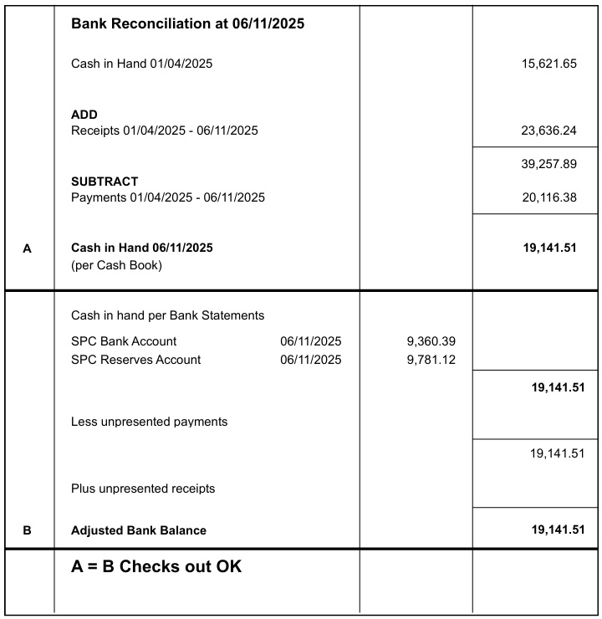

Councillor Mack proposed for the Chair and responsible Finance Officer to sign the Bank Reconciliation dated 6th November 2025, seconded by Councillor Scowen.
25.177.03 To note any receipts and approve payments as per November’s payment schedule.
FOR APPROVAL
 | DATE | EXPENDITURE | PAYMENT METHOD | TOTAL | VAT | P/R NO
Clerk | 12.11.25 | Nov expenses | BACS | £36.72 | £0.00
Clerk | 27.11.25 | Nov Salary and WFH | BACS | £646.80 | £0.00
HMRC | 12.11.25 | Employer NI Contribution up to 5th December | BACS | £57.45 | £0.00
Scribe | 12.11.25 | Accounting Software | BACS | £446.40 | £74.40
AAA Pest Control | 12.11.25 | 3rd quarter pest control | BACS | £112.50 | £0.00
S. Gildersleeve | 15.10.25 | September Invoice | BACS | £45.00 | £0.00
S. Gildersleeve | 15.10.25 | October Invoice | BACS | £100.00 | £0.00
S. Gildersleeve | 15.10.25 | Keys cut | BACS | £18.00 | £0.00
Orange Fox | 12.11.25 | Electrical Installation Condition Report | BACS | £740.77 | £123.46
Orange Fox | 12.11.25 | PAT | BACS | £75.84 | £12.64
R J Plumbing | 12.11.25 | Emergency call out - Leak | BACS | £96.00 | £16.00
TO NOTE PAYMENTS MADE OUTSIDE MEETINGS
Safety Supply | 31.10.25 | Compliant First Aid box | DC | £51.30 | £8.55 | P90
HSE.Gov | 31.10.25 | Accident and Near Miss book | DC | £33.89 | £4.85 | P89
Bookings Clerk/Cleaner | 15.11.25 | Nov Salary | SO | £131.00 | £0.00
Mr S Gildersleeve | 28.11.25 | Nov SAM2 | SO | £15.00 | £0.00
TO NOTE INCOME
 | 24.10.25 | CIL | BACS | £90.00 | £0.00 | R38
 | 28.10.25 | Hall Hire | CHQ | £18.00 | £0.00 | R39
 | 04.11.25 | Hall Hire | BACS | £40.00 | £0.00 | R40
 | 05.11.25 | Hall hire | BACS | £25.00 | £0.00 | R41
Councillor White proposed to approve November’s payment schedule with the clerk confirming salary and PAYE figures upon receipt of her payslip, seconded by Councillor Mummery.
25.178 Flooding:
25.178.01 To consider the Flood and Water Management Team’s Property Flood Resilience.
Councillor Swinborne proposed to submit the responses provided by Councillor Scowen, seconded by Councillor White. The clerk is to ask the Flood and Water Management Team when the council will receive the results of the survey.
25.178.02 Flooding from the Yare – Councillor Scowen to lead.
Councillor Scowen has been in contact with Catherine Harris at the Broads Futures Initiative within the Department of Environment regarding water quality and levels as it is in the process of implementing a 20-year plan for flooding. In 2014 the banks at Postwick were reinforced and their height restored which has influenced flooding within Surlingham leading to at least four areas of the concessionary path often being underwater on the regular twice daily high tides. Ms Harris advised that in her view the poor surface drainage on the Surlingham marshes is the cause of our river flooding problems as the small dykes are not maintained.
Councillor Scowen has been in contact with MP Ben Goldsborough who is researching assistance for flooding in Surlingham.
Several minor dykes on Surlingham marshes should flow into Surlingham Fleet – the channel from the river via Bargate terminating at the Staithe: both the Fleet – the main drainage channel for the marsh system and its tributary dykes are silted up and chocked with reed, impeding effective drainage.
Surlingham has no flood defences, and the Environmental Agency has been taking water level measurement only on the areas it is responsible for.
25.179 To discuss Operation Radium – Trigger Plan.
Operation Radium is Norfolk Police’s response to the growing threat of courier fraud — a type of scam where criminals contact victims by phone, pretending to be from trusted organisations such as the police, government agencies, or banks. Victims are manipulated into withdrawing cash, purchasing high-value items, or sharing sensitive financial information, often under the false promise that the money or items will be returned. If the Police know this is happening in our area the Parish Council will be notified and alerts can be posted on the Website and Facebook pages.
Councillor Mack proposed the council support Operation Radium with details being included in the village newsletter, seconded by Councillor White.
25.180 To receive the Fire, Health and Safety Risk Assessment conducted by Norfolk Fire Protection.
The clerk gave an overview of the report and has started working through the action points starting with the high priority ones:
- 5-year Electrical Installation Condition Report has been conducted and for the report with the annual PAT testing being completed at the same time.
- Implementation of monthly fire equipment checks and emergency lighting checks.
- Purchased a compliant First Aid box, Accident Report and Near Miss books – all of which can be found in the hall kitchen/preparation area.
- Updated the hall noticeboard with current certificates, Health and Safety poster and Emergency Contact information.
Councillor Mummery volunteered to remove the wooden noticeboard from the car park.
25.181 Planning:
25.181.01 Applications:
25.181.01.01 2025/3212 – Talsarn - Upgrade of septic tank with package treatment plant.
Councillor White proposed to submit a support stance on South Norfolk District Council’s planning portal, seconded by Councillor Scowen.
25.181.01.02 2025/3184 – 7 The Street - T1 Oak - Dismantle tree to ground level. T2 Oak - reduce height from 13m to around 9m.
No comment.
25.181.02 Decisions:
25.181.02.01 2025/3050 – Lesingham House – T1 Redwood - dead, fell to ground level. G2 2 x Hawthorn, 1 Sycamore, 1 Buxus, 3 Elms, Hazel stems all dead, fell to ground level; APPROVED WITH CONDITIONS SOUTH NORFOLK DISTRICT COUNCIL.
Noted.
25.181.02.02 2025/3118 – New Barn - Details reserved by condition 9 of 2023/1261 - ecology enhancement measures; APPROVED SOUTH NORFOLK DISTRICT COUNCIL.
Noted.
25.182 Correspondence:
Councillor White informed the council he had been contacted by a parishioner regarding the entrance location to 2 The Green. The clerk has contacted South Norfolk District Council to request further clarity on the approval conditions.
25.183 To receive updates from individual Council Members (for information only).
None.
25.184 To receive any items for inclusion on the next agenda (for information only).
Budget.
Staithe.
Play Area.
25.185 To confirm date and time of the next meeting as Tuesday 9th December 2025 at 7.30pm in Surlingham Village Hall.
Confirmed.

The meeting closed at 21:23pm.

