Surlingham Parish Council

Minutes of the Parish Council meeting held on Tuesday 9th December 2025 in The Village Hall, Surlingham
(Subject to amendment until signed by the Chair at the next meeting)

Parish Councillors present Martin White (Chair), Pam Wilson (Vice-Chair), Dave Swinborne, Pat Scowen, Howard Mummery, Gary Harris, Tim Mack
District Councillor None.
Also in attendance Charlotte Rust, Clerk
Members of the public (MOP) Three

25.186 Welcome from the Chair.
Councillor White opened the meeting at 19:30pm and welcomed all those in attendance.
25.187 To receive and approve apologies for absence.
None.
25.188 To receive any declarations of interest from Members & consider requests for dispensation.
None.
25.189 To approve the minutes of the Parish Council meeting held on 11th November 2025.
Councillor Scowen proposed to approve November’s meeting minutes, subject to the following amendment to minute 25.178.02:
Councillor Scowen has been in contact with Catherine Harris at the Broads Futures Initiative within the Department of Environment regarding water quality and levels as it is in the process of implementing a 20-year plan for flooding. In 2014 the banks at Postwick were reinforced and their height restored which has influenced flooding within Surlingham leading to at least four areas of the concessionary path often being underwater on the regular twice daily high tides. Ms Harris advised that in her view the poor surface drainage on the Surlingham marshes is the cause of our river flooding problems as the small dykes are not maintained.
Councillor Scowen has been in contact with MP Ben Goldsborough whose research assistant facilitated contact between Councillor Scowen and the Internal Drainage Board.
Several minor dykes on Surlingham marshes should flow into Surlingham Fleet – the channel from the river via Bargate terminating at the Staithe: both the Fleet – the main drainage channel for the marsh system and its tributary dykes are silted up and chocked with reed, impeding effective drainage.
Surlingham has no flood defences, and the Environmental Agency has been taking water level measurement only on the areas it is responsible for.
Seconded by Councillor Wilson.
25.190 Matters arising from November’s meeting, including Clerk’s report.
Matters Arising:
- Beerlick’s Loke – South Norfolk District Council is still waiting for a planning application, and the anti-social working hours have been reported.
- Gateways refund – The clerk has contacted Norfolk County Council requesting a partial refund as advised by an employee at the time of placing the gateway order as they were smaller than what was requested in its Parish Partnership 22/23 application. The council has been informed that no refund will be given as there was an increase in fees/installation costs and the cost of the gateways with all additional costs being covered by Norfolk County Council. The clerk requested a breakdown of how much of the increased expenditure resulted from installation delays, and more specifically, what proportion was incurred in rectifying the error involving the initial placement of the wig wag post in a resident’s garden as Surlingham Parish Council should not be held accountable for either of these issues, having provided all required information and financial contributions within the agreed timescales. Norfolk County Council was unable to provide a full breakdown of costs. The clerk is to contact Councillor Thomson to raise the council’s disappointment at the outcome.
- Wig Wag lights – the clerk is to chase this with Norfolk County Council as the wig wag on School Lane’s bottom light remains constantly on.
- Councillor Scowen contact with Ben Goldsborough regarding flooding in Surlingham. Please see minute 25.201.01.
- Entrance to 2 The Green – the clerk contacted South Norfolk District Council asking it to clarify two of the conditions of this planning application:
- The existing vehicular access shall be upgraded in accordance with NCC residential access construction specification for the first 3.0 metres as measured back from the near channel edge of the adjacent carriageway - The existing access will be upgraded from the highway edge, 3 metres back from the highway (marked roughly in pink).
- A 2.4-metre-wide parallel visibility splay shall be provided across the whole of the site’s roadside (The Green) frontage. This means that across the entire boundary of the site shared with The Green, a 2.4-metre-wide parallel visibility area shall be provided meaning that the shrubbery, grass, and general overgrowth should be minimised in this area.
Surlingham Parish Council will monitor the overgrowth as detailed above.
Clerk’s Report:
- There are 22 attendees for January’s training session, from Claxton, Kirby Bedon, Rockland St Mary with Hellington and Surlingham Parish Councils’.
- Waiting for dates in January from Transport Made Simple Group community engagement meeting to discuss No85 bus service.
- Submitted support stance regarding planning application 2025/3212.
- Scanning all council documents so all information is in cloud storage, ready to archive hardcopies at Norfolk County Council.
- Curtains in the hall have been washed and ironed. Thank you to Councillor Swinborne for helping to put the curtains back up.
- Invoices sent for November hall hire, totalling £2,280.48.
- All necessary correspondence forwarded.
25.191 Reports from:
25.191.01 County/District Councillor, Councillor Thomson.
None.
25.191.02 Rivers, Ponds, Cycle/Footpaths.
The clerk read the report received from Richard Atkins:
Pond
The pond is now at a good level again. He will strim the perimeter in the next couple of months and pollard the willows to ensure that they do not get unmanageable and shade the pond. The marginal plants on the South side (Walnut Hill side by the Bench) and West side (Pond Lane side) need addressing this year as part of the management plan (Year 1). He will take a look and let the council know what is required. If it is not too big a job it can be done by hand however if there is a lot to remove a grab lorry may be required.
Pond Management Schedule - Annual
- Check Life Buoy is in situ and functional, twice each year June and December. This is a council function.
- Strim vegetation surrounding the pond and rake into piles for composting or disposal; December – February.
- Pollard the two Weeping Willows near the village sign; December – February.
- Cut back the Goat Willow on the corner of Pond Lane and New Road; December – February.
- Cut and rake out marginal vegetation from a third of the pond edge on a 3-year rotation. This has now been completed for each Zone once and we are back to “Year 1”.
Wherrymans Way
Update from the Broads Local Access Forum on 19th November 2025:
- Though funding and resources are in place to conduct the work, a further hurdle has surfaced which is holding up the Broads Authority planning process. Applications in the Broads Authority national park now must undergo a “Biodiversity net gain test”. The work on Bramerton FP5 involves installing rock mattresses to stabilise the Riverbank. Unfortunately, when the planned work is plugged into the assessment spread sheet the algorithm kicks out a huge financial impact. Though plainly a nonsense this stalled progression and was being worked through. It may have been resolved now but I have not yet seen planning approval confirmed so it may have stopped progress.
- Surlingham FP1 is now impassable and dangerous between its junction with Surlingham FP3 and The Ferry House public house. Regrettably, it will not be possible to conduct the annual litter pick around Church Marsh and along to the Ferry House this winter as it cannot currently be conducted safely. We are still awaiting a response from Caroline Bidwell, Head of Norfolk County Council Trails team, on the feasibility study requested to agree how this right of way is to be restored.
- His previous report ENQ 900276829 appears to have been closed with no action having been taken.
The clerk is to forward Richard Atkins’s report to Councillor Thomson requesting an update and contact the Trails Team regarding Surlingham FP1.
Cycle paths
- The clerk will pick up the replacement ‘No Cycling’ signs ready for installation in January.
25.191.03 Councillor White – Play Area inspection.
Councillor White confirmed the weekly play inspections had been conducted.
25.191.04 Parish Clerk – Traffic and SAM2.
The clerk provided an overview of the data which was from Site 1 (Mill Road facing North) and Site 2 (Mill Road facing South):
- Site two total vehicle count was lower but had a higher average daily count.
- Peak volume on both sites was on a Thursday.
- 1.8% increase in drivers travelling between 26-30 mph at Site 2.
- 0.4% increase in drivers travelling between 31-35 mph and over 35mph at Site 2.
All SAM2 data can be found on the council’s website - Traffic and SAM2 – Surlingham Parish Council
25.192 Adjournment for Public Participation.
A parishioner reported that the island verge near The Green/The Covery/Cut Loke/The Street is encroaching onto the carriageway, forcing vehicles towards the centre of the road. The Clerk will notify Highways.
A parishioner observed that Surlingham Village Hall was not included in the Eleven Says. The Clerk will contact Eleven Says to request that the hall be added to the listings.
A parishioner remarked on the increase in aerial military activity.
25.193 Finance:
25.193.01 To approve budget and precept 2026/2027.
Councillor White proposed increasing the school’s hall hire rate to £10.37 per hour from April 2026, seconded by Councillor Harris. Councillors voted, by show of hands, FOR 7 and AGAINST 0.
Councillor Scowen proposed approving the budget for 2026/2027 and precept of £20,000, seconded by Councillor Harris.
In agreeing next year’s precept, Surlingham Parish Council noted that in recent years its precept has not kept pace with inflation and rising costs, hence over the past 24 months, the Council has drawn approximately £8,000 from its reserves. This necessitated an increase in the 2026-2027 precept. Despite this, the precept remains among the lowest when compared with neighbouring parish councils.
25.193.02 To receive the Bank reconciliation and Statement of Accounts as of 9th December 2025.
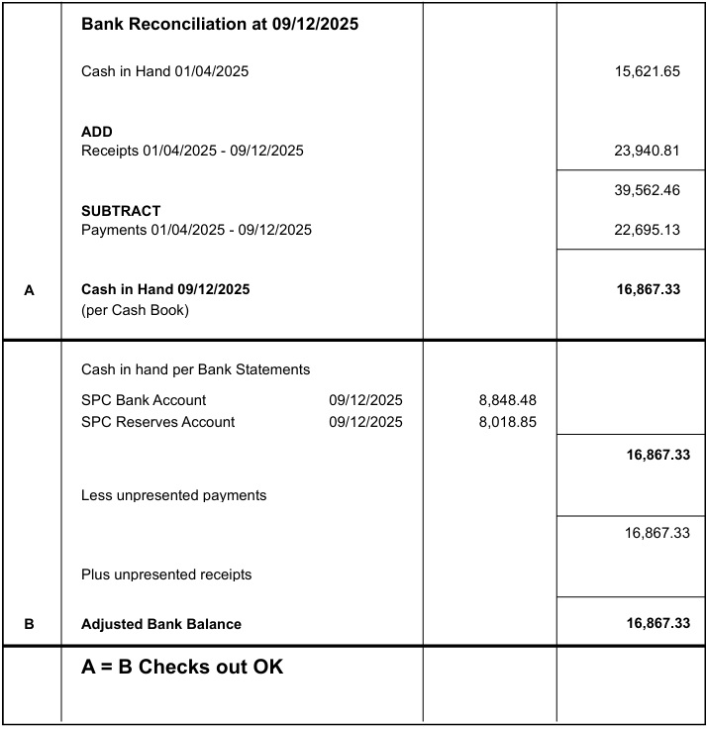

Councillor Mack proposed the Chair and Responsible Finance Officer sign the Bank reconciliation dated 9th December 2025, seconded by Councillor Swinborne.
The Clerk will prepare a report detailing hall receipts and payments over a 12-month period.
25.193.03 To note any receipts and approve payments as per December’s payment schedule.
FOR APPROVAL
 | DATE | EXPENDITURE | PAYMENT METHOD | TOTAL | VAT | P/R NO
Clerk | 10.12.25 | Dec expenses | BACS | £36.72 | £0.00
Clerk | 27.12.25 | Dec Salary and WFH | BACS | £646.60 | £0.00
HMRC | 10.12.25 | Employer NI Contribution up to 5th January 2026 | BACS | £57.45 | £0.00
Hollinger | 10.12.25 | December newsletter | BACS | £46.00 | £0.00
Minuteman Press | 10.12.25 | No Cycling signs | BACS | £17.52 | £2.92
EPC Norfolk LTD | 10.12.25 | Village Hall EPC | BACS | £199.99 | £33.33
TO NOTE PAYMENTS MADE OUTSIDE MEETINGS
EDF | 22.07.25 | Electricity | DD | £564.61 | £94.10 | P55
Amazon | 20.10.25 | Hook and Pole for loft | DC | £9.58 | £1.60 | P86
CT Global | 17.10.25 | Step ladder | DC | £79.79 | £13.30 | P85
EE | 20.11.25 | Wi-Fi | DC | £7.99 | £1.33 | P107
Amazon | 27.11.25 | Fire Logbook | DC | £9.59 | £1.60 | P102
Taryag Rading Ltd | 27.11.25 | Fire exit Signs | DC | £3.99 | £0.67 | P103
Safety First Display Ltd | 27.11.25 | Disabled Access sign | DC | £11.93 | £1.99 | P104
Amazon | 27.11.25 | No Smoking Signs | DC | £11.93 | £1.99 | P105
Bookings Clerk/Cleaner | 15.12.25 | Dec Salary | SO | £131.00 | £0.00
Mr S Gildersleeve | 28.12.25 | Dec SAM2 | SO | £15.00 | £0.00
TO NOTE INCOME
 | 18.11.25 | Hall Hire | BACS | £20.00 | £0.00 | R42
 | 18.11.25 | Hall Hire | CHQ | £90.00 | £0.00 | R43
 | 25.11.25 | Hall Hire | CHQ | £60.00 | £0.00 | R44
 | 26.11.25 | Hall Hire | CHQ | £9.00 | £0.00 | R45
CT Global | 20.11.25 | Step ladder refund | DC | £79.99 | £13.30 | R46
 | 20.11.25 | Hall Hire | CHQ | £18.00 | £0.00 | R47
Barclays | 08.12.25 | Interest | BACS | £27.78 | £0.00 | R48
Councillor White proposed to approve December’s Payment Schedule, seconded by Councillor Harris.
25.194 Planning:
25.194.01 Decisions:
25.194.01.01 2025/3278 – Winbirri Vineyard – Steel portal frame agricultural building – PLANNING PERMISSION REQUIRED SOUTH NORFOLK DISTRICT COUNCIL.
Noted.
25.195 Hall:
25.195.01 To consider water heater replacement quotes.
The clerk met with three contractors:
PVS Plumbing and Heating (quote received)
Clover Plumbing (quote received)
RJ Plumbing and Heating
Councillor White proposed to accept PVS Plumbing and Heating’s quote of £868.83+VAT, seconded by Councillor Harris.
The clerk is to contact PVS Plumbing and Heating to arrange the replacement works.
25.195.02 To consider replacement quote for broken radiator.
The clerk is to purchase radiator covers for the hall as a temporary safety measure, subject to checking with the council’s insurance policy, whilst researching Infra-Red Heating.
25.192.03 To receive Pest Control Inspection Report.
Noted.
25.196 Council Assets:
25.196.01 To receive an update on Litter and Dog bins in the parish.
All Litter and Dog bins are in order.
25.196.02 To receive an update on Grit bin levels in the parish.
Councillor Mummery is to check The Green.
Councillor Mack is to check Mill Road.
Councillor Swinborne is to check Ferry Road.
25.197 To consider and approve Staithe quote.
Following the Internal Drainage Board meeting with the RSPB, the council was advised to hold off any dredging works for 2-3 months until a further update is received.
The clerk is to obtain quotes for felling the Willow Tree.
25.198 To consider clerk’s report recommendation for community consultation on Surlingham play area.
Councillor White proposed to approve the clerk’s recommendation for a community consultation on Surlingham Play Area, acknowledging that there will be overtime for the clerk’s hours and for Councillor Mummery to remove the broken Tractor play equipment, following a Risk Assessment. Seconded by Councillor Scowen.
The clerk is to start the process with the aim of holding the consultation in February half term.
25.199 To consider consultation questionnaire for the Local Government Reorganisation.
The clerk is to submit the council’s responses.
25.200 Policies:
25.200.01 Emergency Plan.
This item is deferred to January’s meeting.
25.201 Correspondence:
25.201.01 Flooding on Cut Loke.
A parishioner had been back in contact regarding the ongoing issue of flooding on Cut Loke/The Green/The Covey. The water is unable to flow through the pipe near the area. Norfolk County Council has cleared the pipe one end, and the landowner is to have a look at what he can do on clearing the other end.
25.202 To receive updates from individual Council Members (for information only).
None.
25.203 To receive any items for inclusion on the next agenda (for information only).
Emergency Plan.
Play Area Consultation update.
Village Hall.
25.204 To confirm date and time of the next meeting as Tuesday 13th January 2026 at 7.30pm in Surlingham Village Hall.
Confirmed.

The meeting closed at 21:32pm.

