Surlingham Parish Council

Minutes of the Annual Parish Council Meeting held on Tuesday 9th April in The Village Hall, Surlingham
(Subject to amendment until signed by the Chair at the next Annual Parish meeting)

Parish Councillors present Chair John Broom, Tim Mack, Pat Scowen, Richard Atkins
District Councillor None
Also in attendance Charlotte Rust – Parish Clerk
Members of the public (MOP) Three

24.43 Welcome from the Chair.
Chair J Broom welcome all those in attendance to the meeting.
24.44 To receive and approve apologies for absence.
Councillors’ D Swinbourne, P Wilson, M White sent their apologies. Councillor V Thomson sent his apologies also.
24.45 To receive any declarations of interest from Members & consider requests for dispensation.
None.
24.46 To approve the minutes of the Parish Council meeting held on 11th April 2023.
Councillor P Scowen proposed for Councillor J Broom to sign the approved minutes, seconded by Councillor R Atkins.
24.47 Finance:
24.47.01 To receive a Statement of Account as of 9th April 2024.
Bank Balance: £7,250.91
Reserves: £18,652.08
24.47.02 To note any receipts and approve payment as per the April payment Schedule.
FOR APPROVAL
 | DATE | EXPENDITURE | PAYMENT METHOD | TOTAL | VAT | P/R NO
Mrs C Rust | 10.04.24 | April expenses | BACS | £20.30 | £0.00
CAN | 10.04.24 | Membership 2024/25 | BACS | £20.00 | £0.00
SSE | 10.04.24 | Electricity 10.23-01.24 | DD | £3,384.25 | £1,176.71
Wave | 12.04.24 | Water 23/25 | BACS | £832.24 | £0.00
TO NOTE PAYMENTS MADE OUTSIDE MEETINGS
Defib4Life | 18.03.24 | New pads | DC | £51.78 | £8.63 | P91
First4Magnets | 08.04.24 | Magnets for noticeboard | DC | £9.53 | £1.59 | P1
R. Hardingham | 15.04.24 | April Salary | SO | £126.67 | £0.00
S. Gildersleeve | 29.04.24 | SAM2 moving | SO | £15.00 | £0.00
Mrs C Rust | 29.04.24 | April Salary & WFH | SO | £480.72 | £0.00
TO NOTE INCOME
 | 12.03.24 | Hall Hire | CHQ | £64.00 | £0.00 | R74
 | 12.03.24 | Hall Hire | CHQ | £40.00 | £0.00 | R75
 | 18.03.24 | Hall Hire | CHQ | £24.00 | £0.00 | R76
 | 21.03.24 | Hall Hire | BACS | £13.33 | £0.00 | R77
 | 22.03.24 | VAT for Oct - Dec | BACS | £417.35 | £0.00 | R78
 | 25.03.24 | Hall Hire | BACS | £112.00 | £0.00 | R79
 | 27.03.24 | Hall Hire | CHQ | £24.00 | £0.00 | R80
 | 27.03.24 | Hall Hire | CHQ | £16.00 | £0.00 | R81
 | 27.03.24 | Hall Hire | CHQ | £80.00 | £0.00 | R82
 | 27.03.24 | Hall Hire | CHQ | £48.00 | £0.00 | R83
 | 28.03.24 | Hall Hire and Electricity | BACS | £2,338.12 | £0.00 | R84
24.48 Annual reports:
24.48.01 County Councillor
None.
24.48.02 District Councillor
None.
24.48.03 Tornados Football Club
None.
24.48.04 Luncheon Club
None.
24.48.05 Padmaloka Buddhist Retreat
January 1st – December 31st, 2023
Padmaloka is registered charity, established in Surlingham in 1976, whose stated charitable objective is the furtherance of the Buddhist religion. We achieve this objective primarily through providing residential retreats for men that enable a depth of Buddhist practice not possible in the midst of daily life. Our tradition also has women’s retreat centres and retreat centres for both men and women.
Last year we ran a full range of retreats, ranging from weekends for those who are newer to Buddhism, to Ordination training retreats, and retreats for ordained Buddhists. Our retreats were well attended and well received. Activities on our retreats include meditation, talks on Buddhism, discussion groups, devotional rituals, and periods of silence. Some meditation retreats are held almost entirely in silence
We ran our first retreat specifically for fathers last year, it was a great success and we’ll be running two a year from now on. Earlier this year we ran our first retreat for men of colour, his was also a great success and we’ll be running two a year from now on. We are the main ordination training centre for men in The UK and Europe, most of our retreats are geared towards this purpose. Most of the men who train for ordination are ordained on a three-month ordination retreat in the mountains of Southern Spain, not everyone is able to do this so 7 men were ordained during a two-week retreat at Padmaloka.
There are 14 of us who currently live at Padmaloka and run the retreats. Around half of the community are on our ordination team and they lead the retreats; the other half are on the support team and they take care of all the practicalities in the background. Those who lead the retreats here also visit other centres to teach and lead retreats, mostly in the UK and Europe, but sometimes further afield. The rest of the community also took part in various outreach activities, leading Buddhist activities In Norwich, Ipswich and Belgium. Last year we undertook an initiative to encourage more volunteering here We also saw an increase in those wanting to come and volunteer with us, mostly from the UK and Europe, but also from as far afield as Mexico and Australia, as well as from Norwich, Brundall, and Beccles.
2023 saw a fair amount of change in the community, most notable was Sthiramani (Tom) leaving us to return to his native Ireland after 16 years with us. Sthiramani contributed a lot to Padmaloka, as well as the village during his time with us, notably being a key member of the Village Fayre organising committee.
We’re looking to find more men to join our community over the next year or two. One thing we’ll be looking into post-Brexit is becoming a visa sponsor, as the pool we have to draw upon from people who are able to live our lifestyle is currently very small.
As a charity, all the money we receive needs to be used to further our charitable objectives. One of the ways we spend the money we receive is by investing in the maintenance and development of our facilities
A whole range of projects were carried out including:
- New yoga and meditation equipment
- Window and roof replacement
- Furniture replacement
- A new website and online database
- Renovating our community lounge
- Creating an extra bedroom in the main house to enable the recruitment of more community members to teach on retreats
The most significant project of the last seventeen years has been covering all the walls of our shrine room with specifically commissioned Buddhist iconography. This has been carried out by a Norwich based Buddhist artist called Aloka. The project is nearing completion with all the walls almost entirely covered and only small gaps left to fill.
We were also fortunate be in a position to donate to an appeal for a women’s retreat centre that oversees the women’s ordination training. They’ve outgrown their premises and are currently looking to move to new ones.
As a charity we take our various legal responsibilities seriously and our council of trustees, as well as our management team make sure that such things as safeguarding, health and safety, financial responsibility etc are all in hand. One thing that was brought to our attention last year are the issues faced by those in wheel chairs and with other accessibility and mobility needs. Addressing this became the focus of our project planning and fundraising. So far this year we’ve been able to replace a quarter of our gravel paths with water permeable block paving. Over the coming months we’ll upgrade our accessible bathroom, install more threshold ramps, and begin installing power assisted door openers. When our tradition was founded in the late 60’s the majority were very young and idealistic. Now that we have a whole range of ages we need to ensure that our elders are still able to come on retreat.
There’s much we’d like to do to improve accessibility, but as always this is all constrained by money, so we’ll do what we can, when we can.
Our relationship with the wider local community is important to us and we look for ways to contribute where we can:
- We hosted various school visits and visited schools as well
- We hosted a free meditation evening in partnership with the Norwich Buddhist centre aimed at the wider local community, which was a great success and will be repeated.
If there are ways we can contribute to the village, then do let us know
At the end of last year I decided to step down as chairman and leave Padmaloka, which I’ll do at the end of the Summer, Satyakirti has put himself to be my successor, and I’m currently training him up in the role.
So this will be my last Surlingham Parish Council AGM It therefore feels particularly poignant to thank the village Surlingham for the warmth, support and friendship you’ve shown Padmaloka, over the years.
I want to thank the Parish Council too. I know it must seem a bit weird sometimes having bunch of Buddhists on the edge of the village, but we appreciate being part of the local community and value our place in it.
24.48.06 Surlingham Primary School
None.
24.48.07 Creative Writers (Off the Page)
Now in our eighth year, we meet regularly on the first Wednesday of each month from 7-9.00pm and have informal writerly catch up’s mid-month at Teles Patisserie on a Tuesday afternoon.
Several members have achieved publishing success since our last annual report- Alexandra Evans’s amazing script, Moldovan Green, was selected for a performance at the INK festival, and was very well received.
Amanda Addison has a new YA book, Looking for Lucie, with Neem Press, launching on Monday 22nd April at Waterstones, Norwich – a few tickets are still available for this.
Karen Francis has been published in several anthologies over the last year and her pamphlet collection, a mother is a paperclip, is due to be published within the next few months by Hedgehog Press. She also participates in several online open-mic events across Norfolk and nationally.
Just as importantly, all members continue to enjoy our gatherings, which tend to be fairly lively. Members also frequently share news and writing informally between meetings, meet up and attend linked interest events together.
In June we held a very successful memoir workshop, Everyone has a story to tell, in Bramerton Village Hall, with the excellent writing tutor Belona Greenwood (Sadly, Surlingham Village Hall is just not conducive to the needs of our small group as we require close parking for members with mobility difficulties/ social events and an appropriate area for a small group to meet regularly). Sadly, our second planned workshop with her in September, Script Writing – putting words in their mouths had to be postponed through poor health but we hope to offer it later this year.
We continue to contribute to Surlingham Church community events with thematic displays of our work and are preparing to offer a something similar in June for their planned Bugs and Beasties event.
We continue to thrive as a very welcoming and nurturing group so would invite any fellow or potential creative writers to come along and see if the group works for you. Prospective new members, or anyone interested in our workshops, just need to contact me, as co-ordinator, Karen Francis (01508 538591), for more details.
24.48.08 Church & Poor Charity
The income for the Charity is generated from leases of marsh, farmland, and the allotments.
Originally, there were two branches of the Charity one for the Church and another for the Poor. Each branch was administered by its Trustees with a separate income stream, Clerk, and bank account.
In August 2021 the Charity Commission approved the combination of the assets and branches into one body of seven Trustees responsible for sharing the income equally between the Church and the Community.
To ensure funds are distributed wisely the Trustees have agreed that from 2024 individuals requesting financial support will be required to provide evidence of their entitlement to Pension Credit and Universal Credit.
The Trustees meet regularly throughout the year and requests for assistance can be made at any time by contacting the Clerk.
The Trustees continue to be proactive in generating income. Leases have again been renewed at an enhanced rate and negotiations for the renewal of others are ongoing.
Disbursements were given to the Church, Four Parishioners, Lunch Club, Gentle Exercise Group, and the Tornadoes Football Club.
Funds have also been ringfenced for the Parish Council to help with the cost of dredging the Staithe.
Trustees of Surlingham Church & Poor Charity
24.48.09 SPATS
Spats continues to be used by a range of parishioners with 45 journeys claimed for last year. The numbers are increasing steadily.
We currently have just over £3000 in our account so in a very healthy position for the scheme to continue.
Norfolk County Council has approved our grant application. It was decided that as our funds are healthy we could reduce our grant to £600 each year for three years. This reduction would then help others in the region who also need funding. We can then review the amount claimed on the next three-year cycle.
Trustees are Heidi Dimmock, Sonia Cox and Bryan Heeler.
Neil at Surlingham garage is still happy for forms to be dropped at their office.
As trustees we may need to consider reviewing the max £10 claim as the cost of taxis to hospital etc have increased.
24.48.10 WI
The Parish Council would like to send its condolences to all the members of WI, following the passing of its President, Monica Payne. Our thoughts are with you.

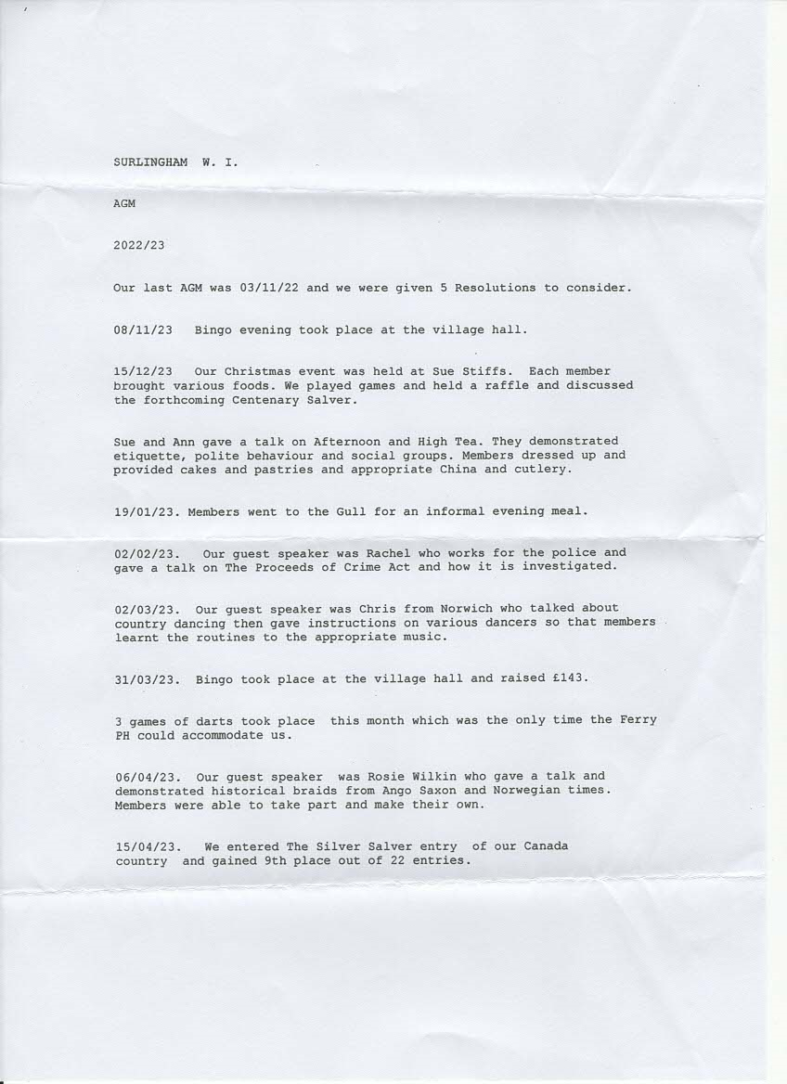
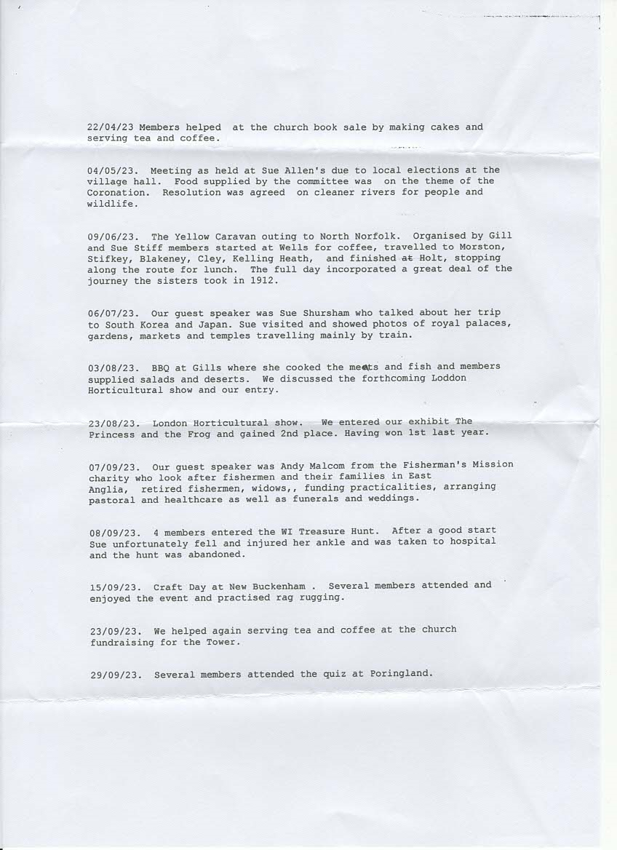



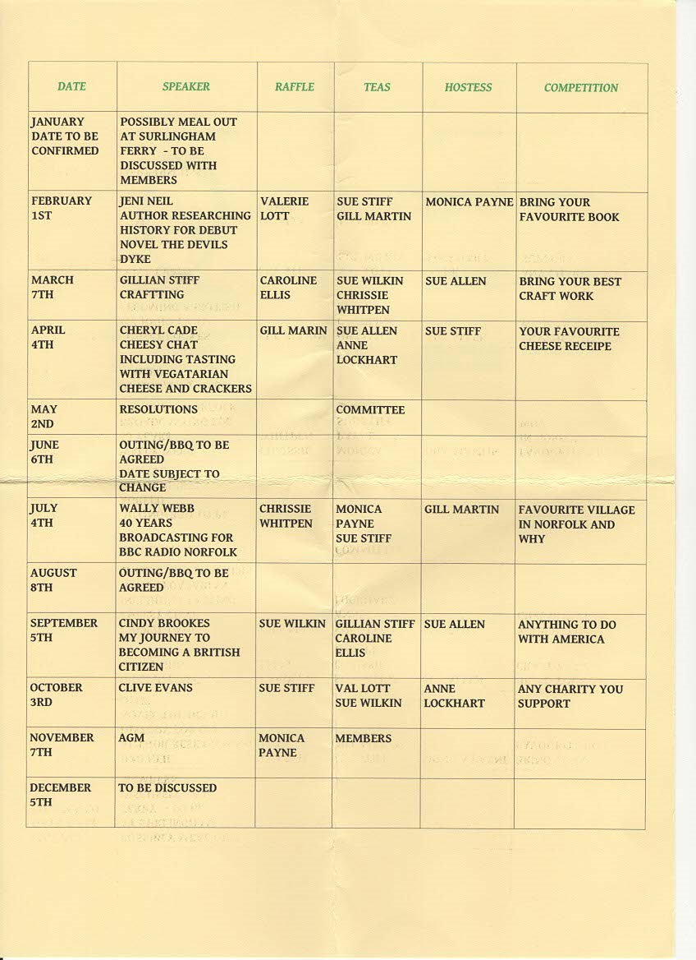
24.48.11 St Mary’s Surlingham
As you know we are focused on qualifying for a Lottery Fund grant to repair the Church Tower, we will also require funds for the church roof. Both the church and St Saviou’s ruin have now been raised to the Heritage Fund ‘At Risk’ Register. We have helping us, on a paid basis, Saul Penfold who has led many similar and educational projects in Norfolk and Suffolk. There is an emphasis on environmental issues which fits with the Parish biodiversity remit.
The church is well sited for community and environmental projects, it is also on a popular walking route. Involvement and support by the community is pivotal to approval for a grant. St May’s is one of 6 churches in the Rockland Benefice which with the Thurton Benefice forms the Bramerton Gorup. Rev. Chris Ellis of Turton Benefice ha been off sick for some time so Nick Garrard has been helping to cover for him. The Group is part of the Loddon Deanery and we have a new Bishop of Thetford.
At St Mary’s we celebrated the Coronation with a flower festival and with butterflies made by many children and adults in the village. The butterflies gave a lot of pleasure to visitors to the church. Similarly, poppies were made for Remembrance Day.
The School held celebrations at Easter, harvest and Christmas in the church, they are always very thoughtful and accompanied by lovely art and written work.
We have Celtic Prayer led by rev. Mandy Ansell. Through winter there has been the weekly Warm Room held at the Barn in Rockland, also and on zoom Art Café. In the Group Lent Course we learned of the work of Emmaus and the redevelopment of All Hallows, Ditchingham. The World Day of Prayer service was put together by Christian women living in Gaza and was very moving. Funds have been raised in the Diocese for Ukraine and Palestine.
With fewer services and church attendance funds are low. We now have an electronic ‘easy to use’ card reader for donations for securely making donations in the church. We are grateful to Ros and Graham Coles who keep the churchyard looking lovely. We have had a botanical survey of the churchyard and St. Saviours made by the Norfolk Wildlife Trust, which gives valuable guidance. Wheatfen are helping with the management of St. Saviors. Cathy Terry gives helpful advice.
There have been a number of funerals in the past year, one being for Phyl Gladwell who gave so much to the church and the community, she is much missed.
Pippa Thurlow, Church Warden
24.48.12 Forest School
None.
24.48.13 Community Orchard
We planted our first 8 fruit trees in the winter season of 2017, and in 2018 put in the perimeter fencing to protect the trees from deer. The following winter season we planted a further 7 trees. Covid interrupted our planting plans but we resumed in the winter season 2021-22, and this winter planted a cherry tree. We have also over the years planted hedging whips along the boundary including 5 blackthorns this year. This is to create a shelter belt and a food/nectar source for bees and birds.
The site is quite challenging for the trees as they need to get their roots down quite a way in order to find water to sustain them over the dry summer spells and it is for this reason that we planted them over a number of years rather than all in one go to ensure the first tranche had established before buying more trees.
When we first set up the boundary fencing we left a gap between the play-garden and the orchard. Initially this was grass but over the intervening period bramble has taken over. Our current focus is knocking-back/removing the bramble as far as possible so that we may plant native hedging species in the space as part of our contribution towards habitat creation and extending biodiversity. We also hope this will deter some parishioners who’ve used the space as a rubbish dump - see below:

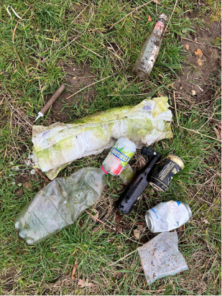

Thanks as always to all the volunteers who help with planting, weeding, and to Richard Ellis for scything the grass around the trees. Thanks too to Cathy Terry who obtained the hedging plants for us and the recently planted cherry tree.
24.48.14 Coldham Hall Sailing Club
Thank you for your kind invitation to attend your AGM meeting representing Coldham Hall Sailing Club. (CHSC). Tonight is our Clubs committee meeting and I offer our apologise, our sailing season started on Sunday 7th April, our Open Regatta is on the 4th & 5th May, Open Day 19th May. Additionally in May, we host a visit from a sailing group from Loch Erne, Ireland, a very busy and active year ahead.
The autumn and spring flooding restricted some activities along with access to the sailing club, we have since carried out a lot of maintenance and repair work, we have strong volunteer support with our membership.
Likewise going forward we have a healthy and vibrant membership both sailing and paddle craft, this includes canoes, kayaks and paddleboards; we offer good value for money, full club house facilities, a full calendar of activities both on and off the water.
This year we will run out Try/ Discover Sailing programme (2023 was fully booked introducing 22 people to the club and sailing). Weekly paddle evenings we had up to 20 people enjoying the river together along with our informal debrief after at both the Tavern and the Ferry.
Locally we work closely with the RSPB and the Broads authority on tree and scrub clearance/conservation, we encourage birds and bugs and collect rubbish from the river when we paddle.
If you recall my visit last year, we anticipate the warm days of summer will bring wild swimmers and those who choose to dive into the river, we continue to advise and warn people of the dangers, additionally the water quality is a great concern, the rain fall and flooding has highlighted the increased pollutants and contaminates present.
We will again pass warnings and advice on to the local schools; we ask the Parish Councils continued support with these warnings.
All members of the Parish Council and residents are warmly invited to visit Coldham Hall Sailing club. A lot of information on activities and events can be found on our web site www.coldhamhallsailingclub.co.uk
or please contact me at mooringsecretary@coldhamhallsailingclub.co.uk
Yours sincerely
Gary Corbett
Commodore, Coldham Hall Sailing Club, Surlingham.
(CHSC is affiliated with the Royal Yachting Association).
24.48.15 Bowls
Surlingham Carpet Bowls club is in its 14th year. We struggle with numbers due to illness and age.
Currently we have 14 permanent members two of which have had significant health issues luckily we have two members join us from Rockland St Mary. They are our youngest members and are very friendly, helpful and a pleasurable addition. We are able to celebrate Christmas 2023 with a lunch at the Old Feathers half of which was paid by the club.
We still only charge £2 for a 2-hour session with tea and biscuits. We meet every Friday night 6.45 to 8.45pm in the Parish Hall.
24.48.16 Surlingham.org
Surlingham.org continues to provide a forum by which local organisations and businesses can post and send an email to 350+ people who have signed up to receive posts. It also provides static pages about the village and its amenities to help locals, visitors and holiday makers. The site receives upwards of 1500 individual web site visitors a month.
Surlingham.org is independent of social media platforms and free from advertising. As such, content can be moderated. It is run and financed independently.

