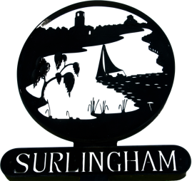
SURLINGHAM PARISH COUNCIL
The Parish Council meetings are open to the public to observe, they are not public meetings. There is the opportunity for the public to ask questions at every meeting.
Members
You are summoned to attend the meeting of Surlingham Parish Council to be held on Tuesday 17 January 2023 at the Parish Hall at 7.30pm in line with standing orders the meeting will close no later than 9:30.
Janet Rogers Parish Clerk
Tel: 01508 538921
Agenda.

- Welcome by the Chairman
- Apologies and approval of absences
- Declarations of Interest
- To approve as accurate the minutes of the meeting on 20 December 2022
- Matters arising from those minutes
- Progress report for information on items not on the agenda: Councillors/Clerk
- To receive reports from the County and District Councillor
- Public Question Time
- Finance –
- Authorise Payments
- Approve Quarterly statement 31 December 2022
- Staithe – Response from the Church & Poor Charity
- Play Park – Maintenance plan
- Approve a resolution to exclude the public and press from item 16 because their presence would be prejudicial to the public interest due to the confidential nature (Public Bodies Admission to meetings Act 1960)
- Consider applicants for position of Parish Clerk
- Date of next meeting 21 February 2023

