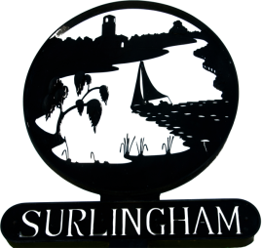
SURLINGHAM PARISH COUNCIL
The Parish Council meetings are open to the public to observe, they are not public meetings. There is the opportunity for the public to ask questions at every meeting.
Members
You are summoned to attend the meeting of Surlingham Parish Council to be held on Tuesday 21 February 2023 at the Parish Hall at 7.30pm in line with standing orders the meeting will close no later than 9:30.
Janet Rogers Parish Clerk
Tel: 01508 538921
Agenda.

- Welcome by the Chairman
- Apologies and approval of absences
- Declarations of Interest
- To approve as accurate the minutes of the meeting on 17 January 2022
- Matters arising from those minutes, Chair to report on Item 13 Appointment of Clerk
- Progress report for information on items not on the agenda: Councillors/Clerk
- To receive reports from the County and District Councillor
- Public Question Time
- Approve appointment of Parish Clerk and change of Council meetings to second Tuesday of the month.
- Planning Permission 2023/0137 Residential dwelling north of The Green.
- Correspondence – 1) Request for additional Dog Bin in The Covey nearer Wheatfen. 2)
Complaint – Finials on new entrance to The Manor are unsightly and contravening planning application 2022/1560 ball finials have been replaced with WCs
- Hall – MW paper on projected receipts and payments. Agree increase in hire charges April 2023, ongoing Management, current repairs required to Kitchen (door and socket)
- Finance – Authorise Payments
- Cyclists using footpaths
- Date of next meeting 14 March 2023

